**TBMS**

**-by TBT**

**A**

**PROJECT REPORT**

**ON**

**BANK MANAGEMENT SYSTEM**

**For**

Partial Fulfillment of Degree

**Submitted**

**By**

**(TBT|Kirito 何睿鹏 & Gunly 杨江利 & Jerry 张捷 & Paul 侯喜龙 |START DATE:2019·05·11|END DATE:2019·05·23)**

**Registration No.9911001**

** **

**THANKS FOR HELP**

**  **

**MR.Ashu & 刘德才先生**

**PROJECT INDEX**

|  |  |  |
| --- | --- | --- |
| **S no.** | **Particulars** | **Page no.** |
| **1** | **ABOUT TEAM** | **5** |
| **2** | **ACKNOWLEDGEMENT** | **6-7** |
| **3** | **Requirement**  **SDLC**  **SOFTWARE DESIGN** | **8-15** |
| **4** | **DATABASE DESIGN** | **16-18** |
| **5** | **USE CASE DIAGRAM** | **19-20** |
| **6** | **TESTING&DEBUGGING** | **21-25** |
| **7** | **OTHERS** | **26-28** |
| **8** | **CODE** | **29-92** |

**TEAM DESCRIPTION**

“**T**he Best Team”(**TBT**)was created in 2018·11·01 ,we have 4members (*Kirito,Gunly,Jerry,Paul*)in this family.

**We are committed to the perfect completion of every project.**

**E**veryone in this team has his own special skills,we work together,and we have a clear division of labour.

**WE BELIEVE THAT WE WILL GET GREAT ACHIEVEMENT.**

**ACKNOWLEDGEMENT**

**First of all, please allow me to express my heartfelt thanks to all members of TBT on behalf of everyone who has helped us.The completion of this project can not be separated from the support and helpof all these people.**

**As you can see, TBMS is a difficult project, and our team members have made great efforts for it, but one of the reasons why it succeeds is that we have the help of Mr.Ashu and Mr.Liu.**

**Mr.Ash helped us a lot in completing and revising the report and answering some questions.**

**Mr.Liu has helped us a lot with technical issues such as how to insert pictures into the interface.**

**On behalf of the members of the group, I would like to thank youonce again!**

**Let me also offer my loftiest thanks to the website that helps us solve our doubts.**

**Finally, on behalf of myself, I would like to express my gratitude to the team members who have worked day and night for the project.**

**PROJECT REPORT**

**B**ank is one of the infrastructure that every country must have.

**A**s we know,the workload of banks is huge and complex,and banks must deal with problems ina timely manner.

**I**n order to facilitate bankmanagement,it is necessary to use the bank management system(**BMS**).

**H**ere is a more feasible project for you to choose——**T-BMS**.

**T-BMS** is the abbreviation of our R&D project(**TBT-BANK MANAGEMENT SYSTEM**),It is reliable helper for managing banks.

In order to run **TBMS** perfectly,you need to prepare the following.

**·SOFTWARE REQUIREMENTS**

·JavaSE-1.6

·MySQL(at least 5.7)

·Any IDE like Eclipse (2019-03)

When using this system,you need to fill in a lot of data,but under our design,these problems will become very simple.

The following descriptions will help you better understandhow our software is designed and worked.

**·SDLC OF THE PROJECT**

**T**his project is a application on WINDOWS and going to be developed using J2EE technology like JDBC,JSP and some others.The SDLC of this project will bediscussed under following heads.

**REQUIREMENT ANALYSIS**

**B**efore starting the project,the first thing which should beconsidered are the requirements.

The requirements to be filled bu the new system can be uncoverde through a proper analysis of the existing system for its problems this is know an requirement analysis.

·**Enter information about queries and binding customers.**

**W**e have designed a system to quickly bind bank cards to customer information. In each use,the input information should include details of the customer,including name,age, address, ID number, etc. On the one hand, these information will help customers to handle and consult various business in the future, on the other hand, the improvement of information will also help the system run accurately and quickly.

**·The second important part is about the simple and effective**

**modification of customer information in the database to facilitate and quickly handle the business customers need.**

**W**e use more convenient and effective code to make our system more perfect, on the other hand, it also improves the portability of our system. These codes enable our system to have a perfect operating interface, a simple operating process, and a comfortable operating experience.

**SOFTWARE DESIGN**

**H**ow to make the system satisfying, fast and convenient to users is our general goal of design.Likebuilding a house, appearance design, interior design and structure design are the main directions of our research.

**·appearance design**

**·interior design**

**·structure design**

**·appearance design**

**G**ood appearance design will give users a comfortable experience.For this reason, we will design a beautiful operation interface, appropriate background image, and skillfully use the technology of putting pictures into database or inserting pictures in Java. The concise and elegant use interface of TBMS is the result of skilled use of this technology.

**·interior design**

**G**ood internal design embodies the logic of designing programs. On the other hand, it helps users find every part they need more easily when using software. The internal layout of **TBMS** is rigorous and everything is clear at a glance, which benefits from the team's unremitting efforts to perfect the internallayout.

**·structure design**

**S**tructure design is the soul of the whole program. This line of logical code constitutes our perfect system. Every code has its own functions. Every line of statement is used properly. These codes constitute the following parts of our software.

**·Login interface**

**·System Main Interface**

**·Business Interface**

**·Exit interface.**

**Login interface**

**T**his interface makes sure thatall access to the system is properand authenticated. All the links and navigation paths are available for manipulating any kink of information only after an authorized person enters a valid set of user IDand PASSWORD. So this module serveas an entry point for the system and only the authorized person can access it.

**System Main Interface**

**T**he main interface ensures thefeasibility of each interface mounted on it, and it is also the foundation of our system.As you can see, the design of the main interface is also the core of the whole system.

**Business Interface**

**T**he Business Interface, it includes the parts that each customerneeds, or the parts that bank employees need to operate He realizes the interaction between bank employees and the system, and is also the fastest and most effective way for bank employees to handle business for customers.

**Exit interface**

**S**ecure and privacy-free exit system is a perfect exit interface. The design of TBMS enables bank employees to completely eliminate the traces of login system when they exit the system.On the one hand,it greatly improves the security of the banking system and the privacy of customer information.

**DATABASE DESIGN**

|  |  |  |  |  |
| --- | --- | --- | --- | --- |
| **Field name** | **Data type** | **Size** | **Primary key** | **null** |
| **Card number** | **int** | **6** | **Y** | **N** |
| **job number** | **int** | **7** | **Y** | **N** |
| **Name** | **Varchar** | **20** | **N** | **N** |
| **Sex** | **Char** | **1** | **N** | **N** |
| **Age** | **Int** | **3** | **N** | **N** |
| **ID card** | **Int** | **18** | **N** | **N** |
| **Password** | **int** | **7** | **N** | **N** |
| **Photo** | **blob** |  | **N** | **N** |
| **Bank card** | **int** | **6** | **Y** | **N** |
| **ID_card** | **Big int** | **18** | **N** | **N** |
| **Name(customers)** | **Varchar** | **20** | **N** | **N** |
| **Sex** | **char** | **1** | **N** | **N** |
| **Eg** | **Varchar** | **5** | **N** | **N** |
| **TEL** | **Big int** | **11** | **N** | **N** |
| **Address** | **Varchar** | **20** | **N** | **N** |
| **Balance** | **Int** | **12** | **N** | **N** |
| **Missing** | **char** | **1** | **N** | **N** |
| **Password (customers)** | **int** | **6** | **N** | **N** |
| **Gold** | **Int** | **12** | **N** | **N** |
| **Deal time** | **Varchar** | **30** | **N** | **N** |
| **Deal style** | **Varchar** | **10** | **N** | **N** |
| **Deal money** | **Int** | **12** | **N** | **N** |

**USE CASE DIAGRAM**

Requirement Doubt query handle

...

MainSystem Subsystem Related interface Related operations

...

TBMS

.

bank staff

customer

**Operational Flow Chart**

Loging=

Main system

subsystem

Exit system

Handle the business

Enter information

.

**TESTING&DEBUGGING**

**Software testing is an execution process of a program. Thepurpose is to find and correct the errors in the tested software as far as possible and to improve the reliability of the software.**

**It is a very important and complex work in the software life cycle,and it is of great significance for software reliability assurance.**

**To this end, our team conducted some tests on TBMS:**

1. **Unit testing: Testing the smallest visual unit for code. ·Follow the principles:**

**(1) Make sure that each test case is as independent as possible.**

1. **Generally implemented by the developer of the code**

**In this test, code developer Gunly found the following errors: ·No error.**

**2.Integration testing (excuse between modules): On the basis of unit testing, testing whether the work of each part of the process of assembling all software units into (modules, subsystems or systems)in accordance with the requirements of the outline design specification meets or achieves the corresponding technical specifications andrequirements.**

**·Implementation plan: Assemble all things (whether completed) and test after assembly (whether upto standard)**

**In this test, tester Paul Jerry found the following errors: · The image (JLebel) on JComboBox is not displayed properly.**

**Rewrite getListCellRenderer Component by JComboBox's setRenderer method, change the return value to JLebel, and return to normal after testing. · Errors (Carton and program exceptions) are found when switching between interfaces (blocks)**

**Each interface (block) is changed to inherit the form of JPanel and initialized separately byusing JPanel arrays.**

**3. System Testing (Function andPerformance): Taking the integrated testing software as a part of the computer system and combining it with other parts of the system, a series of rigorous and effectivetests of the computer system are carried out under the sub-actual operating environment to discover potential problems of the software and ensure the normal operation of the system.**

**In the final test, tester Kirito & Gunly found the following problems:**

**· Software interface fails to adapt well at other resolutions**

**Change the absolute design of page component size and font size to relativity (font and component size can be adjusted)**

**· Software interface layout is slightly cumbersome, affecting user experience**

**Redesign software interface, simplify repetitive unnecessary design, optimize interface code and improve code readability.**

**Task Distribution**

|  |  |  |  |  |
| --- | --- | --- | --- | --- |
| **WORK DONE BY** | **WORK TASK** | **STARTING DATE（April）** | **ENDING DATE（May）** | **DURATION(DAY)** |
| **Kirito&Paul** | **Create database** | **4·29** | **5·15** | **17** |
| **Gunly** | **Finish JDBC** | **4·29** | **5·15** | **17** |
| **Kirito** | **Report writing** | **5·12** | **5·22** | **10** |
| **Jerry** | **Art layout** | **4·29** | **5·21** | **22** |
| **Gunly&Jerry&Paul** | **Interface design** | **4·29** | **5·21** | **22** |
| **Paul&Jerry** | **Testing** | **5·12** | **5·22** | **10** |
| **Gunly&Kirito** | **Debugging** | **5·12** | **5·22** | **10** |

**·Economic effect**

**T**his software has been developed in 22 days, our team works onthis project at least 7hours a day.

**T**he total hours = 22 * 7 = 154

Estimated the working cost of manpower is $10/h.

**T**hen the total of the project is

154 * 10 = 1540.

**S**o the Estimated Total Cost ofthe Project is One Thousand,Five hundreds,Forty .

**·ABOUT CODE**

**A**s you know, our software is completely open code, which will help improve the software and increase the user experience.

**I**n addition, if you have any questions about any part of the software, please contact us:

***1597230196@qq.com→KIRITO***

***18109418765→KIRITO***

**THE CODES ARE ON THE NEXT PAGE.**

**PART OF JAVA**

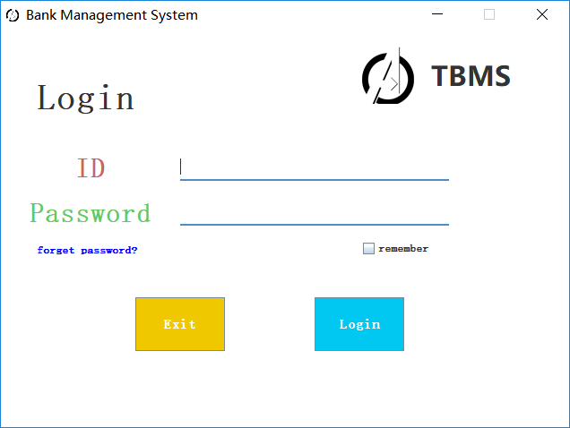

**//Start.java**

**package com.tbt.banksystem;**

**import java.awt.Font;**

**import java.awt.Toolkit;**

**import java.io.File;**

**import java.io.FileInputStream;**

**import java.io.FileNotFoundException;**

**import java.io.IOException;**

**import java.io.InputStream;**

**import java.sql.Connection;**

**import java.sql.DriverManager;**

**import java.sql.PreparedStatement;**

**import java.sql.ResultSet;**

**import java.sql.SQLException;**

**import java.sql.Statement;**

**import java.text.SimpleDateFormat;**

**import java.util.Calendar;**

**public class Start {**

**private static Signin signIn;**

**private static BankSystem bankSystem;**

**private static String url = "jdbc:mysql://localhost:3306/BANK_SYSTEM?useSSL=false",**

**user = "root",**

**password = "";**

**private static Connection con;**

**private static Statement sta;**

**private static ResultSet res;**

**public static int width = Toolkit.getDefaultToolkit().getScreenSize().width,**

**height = Toolkit.getDefaultToolkit().getScreenSize().height;**

**public static Font useFont = new Font("宋体", Font.BOLD, width / 100),**

**font25 = new Font("微软雅黑", Font.BOLD, width / 80),**

**font30 = new Font("微软雅黑", Font.BOLD, width * 3 / 200),**

**font40 = new Font("微软雅黑", Font.BOLD, width / 50),**

**font50 = new Font("微软雅黑", Font.BOLD, width / 40);**

**public static void main(String[] args) {**

**try {**

**Class.forName("com.mysql.jdbc.Driver");**

**con = DriverManager.getConnection(url, user, password);**

**sta = con.createStatement();**

**} catch (ClassNotFoundException e) {**

**e.printStackTrace();**

**} catch (SQLException e) {**

**e.printStackTrace();**

**}**

**new Start();**

**signIn = new Signin();**

**}**

**public static void logIn(String loginname, String loginnum) {**

**signIn.setVisible(false);**

**bankSystem = new BankSystem(loginname, loginnum);**

**}**

**public static void logOut() {**

**bankSystem.dispose();**

**signIn.setVisible(true);**

**}**

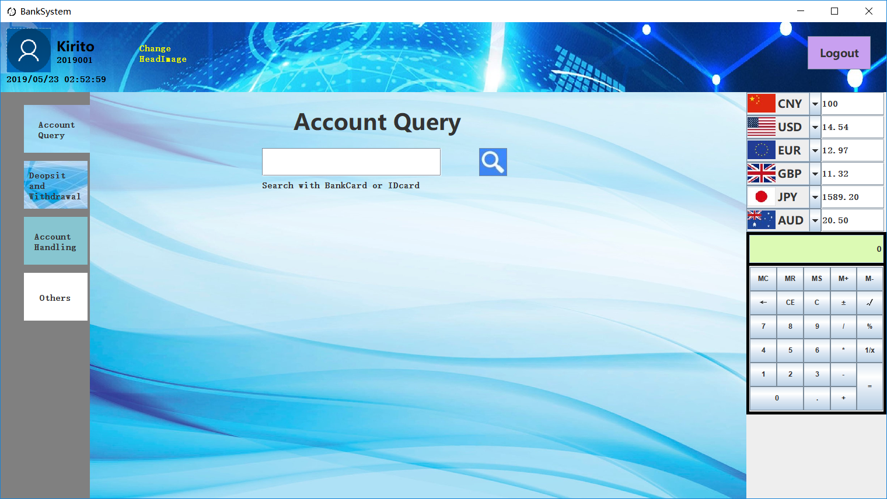

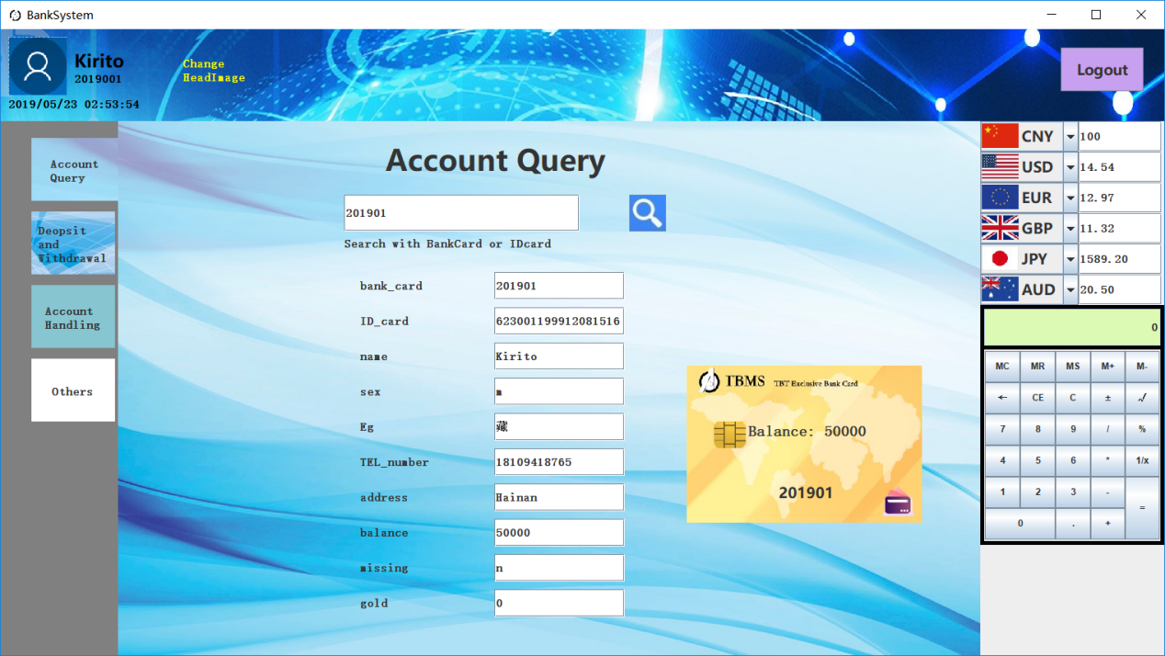

**//Signin.java**

**package com.tbt.banksystem;**

**import java.awt.Color;**

**import java.awt.Dimension;**

**import java.awt.Font;**

**import java.awt.event.KeyAdapter;**

**import java.awt.event.KeyEvent;**

**import java.awt.event.MouseAdapter;**

**import java.awt.event.MouseEvent;**

**import javax.swing.ImageIcon;**

**import javax.swing.JButton;**

**import javax.swing.JCheckBox;**

**import javax.swing.JFrame;**

**import javax.swing.JLabel;**

**import javax.swing.JPanel;**

**import javax.swing.JPasswordField;**

**import javax.swing.JTextField;**

**import javax.swing.border.MatteBorder;**

**public class Signin extends JFrame{**

**private JLabel wrongLabel;**

**private JLabel forgetPassword;**

**private JCheckBox rememberPassword;**

**private JTextField idField, checkidField, checkIDField;**

**private LoginPanel signinPanel, forgetPanel, resetPanel;**

**private JPasswordField passwordField, passwordField1, passwordField2;**

**private ImageIcon icon = new ImageIcon(getClass().getResource("/com/tbt/banksystem/image/systemIcon.jpg"));**

**public Signin() {**

**setTitle("Bank Management System");**

**setIconImage(icon.getImage());**

**signinPanelini();**

**forgetPanelini();**

**resetPanelini();**

**this.add(signinPanel);**

**setSize(640, 480);**

**setResizable(false);**

**setLocationRelativeTo(null);**

**setDefaultCloseOperation(DISPOSE_ON_CLOSE);**

**setDefaultCloseOperation(EXIT_ON_CLOSE);**

**setVisible(true);**

**}**

**private void signinPanelini() {**

**signinPanel = new LoginPanel("Login", "ID", "Password", "Exit", "Login");**

**JLabel imgLabel = new JLabel(new ImageIcon(getClass().getResource("/com/tbt/banksystem/image/systemIcon.jpg")));**

**imgLabel.setBounds(400, 20, 64, 64);**

**signinPanel.add(imgLabel);**

**JLabel nameLabel = new JLabel("TBMS");**

**nameLabel.setFont(Start.font40);**

**nameLabel.setBounds(480, 20, 192, 64);**

**signinPanel.add(nameLabel);**

**idField = new JTextField();**

**idField.setFont(Start.useFont);**

**idField.setBounds(200, 140, 300, 30);**

**idField.setBorder(new MatteBorder(0, 0, 2, 0, new Color(80, 140, 200)));**

**idField.addKeyListener(new KeyAdapter() {**

**@Override**

**public void keyPressed(KeyEvent e) {**

**if(e.getKeyCode() == KeyEvent.VK_ENTER)**

**passwordField.requestFocus();**

**}**

**});**

**signinPanel.add(idField);**

**passwordField = new JPasswordField();**

**passwordField.setFont(Start.useFont);**

**passwordField.setBounds(200, 190, 300, 30);**

**passwordField.setBorder(new MatteBorder(0, 0, 2, 0, new Color(80, 140, 200)));**

**passwordField.addKeyListener(new KeyAdapter() {**

**@Override**

**public void keyPressed(KeyEvent e) {**

**if(e.getKeyCode() == KeyEvent.VK_ENTER)**

**loginClick();**

**}**

**});**

**signinPanel.add(passwordField);**

**forgetPassword = new JLabel("<html>forget password?</html>");**

**forgetPassword.setFont(new Font("宋体", Font.BOLD, Start.width * 3 / 400));**

**forgetPassword.setForeground(Color.BLUE);**

**forgetPassword.setBounds(40, 220, 150, 50);**

**forgetPassword.addMouseListener(new MouseAdapter() {**

**@Override**

**public void mouseClicked(MouseEvent e) {**

**forgetPassword.setText("<html>forget password?</html>");**

**signinPanel.remove(wrongLabel);**

**setContentPane(forgetPanel);**

**repaint();**

**}**

**@Override**

**public void mouseEntered(MouseEvent e) {**

**forgetPassword.setText("<html><u>forget password?</u></html>");**

**}**

**@Override**

**public void mouseExited(MouseEvent e) {**

**forgetPassword.setText("<html>forget password?</html>");**

**}**

**});**

**signinPanel.add(forgetPassword);**

**rememberPassword = new JCheckBox("remember");**

**rememberPassword.setFont(new Font("宋体", Font.BOLD, Start.width * 3 / 400));**

**rememberPassword.setBounds(400, 220, 100, 50);**

**rememberPassword.setBackground(Color.WHITE);**

**signinPanel.add(rememberPassword);**

**wrongLabel = new JLabel("Password Wrong");**

**wrongLabel.setFont(Start.useFont);**

**wrongLabel.setForeground(Color.RED);**

**wrongLabel.setBounds(150, 240, 400, 50);**

**signinPanel.btn1.addKeyListener(new KeyAdapter() {**

**@Override**

**public void keyPressed(KeyEvent e) {**

**if(e.getKeyCode() == KeyEvent.VK_ENTER)**

**System.exit(0);**

**}**

**});**

**signinPanel.btn1.addMouseListener(new MouseAdapter() {**

**@Override**

**public void mouseClicked(MouseEvent e) {**

**System.exit(0);**

**}**

**});**

**signinPanel.btn2.addKeyListener(new KeyAdapter() {**

**@Override**

**public void keyPressed(KeyEvent e) {**

**if(e.getKeyCode() == KeyEvent.VK_ENTER)**

**loginClick();**

**}**

**});**

**signinPanel.btn2.addMouseListener(new MouseAdapter() {**

**@Override**

**public void mouseClicked(MouseEvent e) {**

**loginClick();**

**}**

**});**

**}**

**private void loginClick() {**

**String id = idField.getText();**

**if(Start.Check(1, id, new String(passwordField.getPassword()))) {**

**if(!rememberPassword.isSelected())**

**passwordField.setText(null);**

**signinPanel.remove(wrongLabel);**

**Start.logIn(Start.getName(id), id);**

**}**

**else {**

**wrongLabel.setText("Check your password");**

**signinPanel.add(wrongLabel);**

**repaint();**

**}**

**}**

**private void forgetPanelini() {**

**forgetPanel = new LoginPanel("Check", "job number", "ID card", "Back", "Next");**

**checkidField = new JTextField();**

**checkidField.setFont(Start.useFont);**

**checkidField.setBounds(200, 140, 300, 30);**

**forgetPanel.add(checkidField);**

**checkIDField = new JTextField();**

**checkIDField.setFont(Start.useFont);**

**checkIDField.setBounds(200, 190, 300, 30);**

**forgetPanel.add(checkIDField);**

**forgetPanel.btn1.addKeyListener(new KeyAdapter() {**

**@Override**

**public void keyPressed(KeyEvent e) {**

**forgetPanel.remove(wrongLabel);**

**setContentPane(signinPanel);**

**repaint();**

**}**

**});**

**forgetPanel.btn1.addMouseListener(new MouseAdapter() {**

**@Override**

**public void mouseClicked(MouseEvent e) {**

**forgetPanel.remove(wrongLabel);**

**setContentPane(signinPanel);**

**repaint();**

**}**

**});**

**forgetPanel.btn2.addKeyListener(new KeyAdapter() {**

**@Override**

**public void keyPressed(KeyEvent e) {**

**forgetnext();**

**}**

**});**

**forgetPanel.btn2.addMouseListener(new MouseAdapter() {**

**@Override**

**public void mouseClicked(MouseEvent e) {**

**forgetnext();**

**}**

**});**

**}**

**private void forgetnext() {**

**if(Start.Check(2, checkidField.getText(), checkIDField.getText())) {**

**forgetPanel.remove(wrongLabel);**

**setContentPane(resetPanel);**

**repaint();**

**setVisible(true);**

**}**

**else {**

**wrongLabel.setText("Check your input");**

**forgetPanel.add(wrongLabel);**

**repaint();**

**}**

**}**

**private void resetPanelini() {**

**resetPanel = new LoginPanel("Reset password", "Password", "Confirm", "Back", "Finish");**

**passwordField1 = new JPasswordField();**

**passwordField1.setFont(Start.useFont);**

**passwordField1.setBounds(200, 140, 300, 30);**

**resetPanel.add(passwordField1);**

**passwordField2 = new JPasswordField();**

**passwordField2.setFont(Start.useFont);**

**passwordField2.setBounds(200, 190, 300, 30);**

**resetPanel.add(passwordField2);**

**resetPanel.btn1.addKeyListener(new KeyAdapter() {**

**@Override**

**public void keyPressed(KeyEvent e) {**

**if(e.getKeyCode() == KeyEvent.VK_ENTER) {**

**resetPanel.remove(wrongLabel);**

**setContentPane(forgetPanel);**

**repaint();**

**}**

**}**

**});**

**resetPanel.btn1.addMouseListener(new MouseAdapter() {**

**@Override**

**public void mouseClicked(MouseEvent e) {**

**resetPanel.remove(wrongLabel);**

**setContentPane(forgetPanel);**

**repaint();**

**}**

**});**

**resetPanel.btn2.addKeyListener(new KeyAdapter() {**

**@Override**

**public void keyPressed(KeyEvent e) {**

**if(e.getKeyCode() == KeyEvent.VK_ENTER)**

**resetpasswordfinish();**

**}**

**});**

**resetPanel.btn2.addMouseListener(new MouseAdapter() {**

**@Override**

**public void mouseClicked(MouseEvent e) {**

**resetpasswordfinish();**

**}**

**});**

**}**

**private void resetpasswordfinish() {**

**if(!String.valueOf(passwordField1.getPassword()).equals("")) {**

**if(String.valueOf(passwordField1.getPassword()).equals(String.valueOf(passwordField2.getPassword()))) {**

**Start.updatePassword(new String(passwordField1.getPassword()), checkidField.getText());**

**checkidField.setText(null);**

**checkIDField.setText(null);**

**passwordField1.setText(null);**

**passwordField2.setText(null);**

**passwordField.setText(null);**

**resetPanel.remove(wrongLabel);**

**setContentPane(signinPanel);**

**}**

**else {**

**wrongLabel.setText("Password should be same!");**

**resetPanel.add(wrongLabel);**

**}**

**}**

**else {**

**wrongLabel.setText("Password cannot be empty!");**

**resetPanel.add(wrongLabel);**

**}**

**repaint();**

**}**

**class LoginPanel extends JPanel{**

**public JButton btn1;**

**public JButton btn2;**

**public LoginPanel(String title, String feild1, String field2, String textbtn1, String textbtn2) {**

**setLayout(null);**

**setPreferredSize(new Dimension(600, 400));**

**setBackground(Color.WHITE);**

**JLabel mainLabel = new JLabel(title);**

**mainLabel.setFont(new Font("宋体", Font.BOLD, 40));**

**mainLabel.setBounds(40, 50, 360, 50);**

**add(mainLabel);**

**JLabel lable1 = new JLabel(feild1, JLabel.CENTER);**

**lable1.setFont(new Font("宋体", Font.BOLD, 30));**

**lable1.setBounds(0, 130, 200, 50);**

**lable1.setForeground(new Color(200, 100, 100));**

**add(lable1);**

**JLabel label2 = new JLabel(field2, JLabel.CENTER);**

**label2.setFont(new Font("宋体", Font.BOLD, 30));**

**label2.setBounds(0, 180, 200, 50);**

**label2.setForeground(new Color(100, 200, 100));**

**add(label2);**

**btn1 = new JButton();**

**btn1.setText(textbtn1);**

**btn1.setFont(Start.useFont);**

**btn1.setBounds(150, 300, 100, 60);**

**btn1.setBackground(new Color(240, 200, 0));**

**btn1.setForeground(Color.WHITE);**

**add(btn1);**

**btn2 = new JButton();**

**btn2.setText(textbtn2);**

**btn2.setFont(Start.useFont);**

**btn2.setBounds(350, 300, 100, 60);**

**btn2.setBackground(new Color(0, 200, 240));**

**btn2.setForeground(Color.WHITE);**

**add(btn2);**

**}**

**}**

**}**

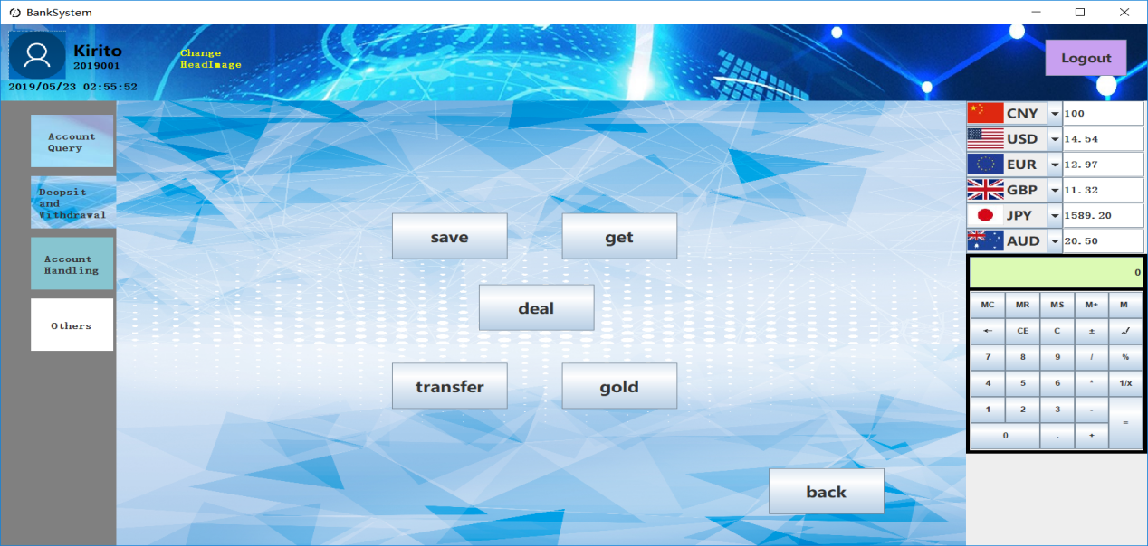

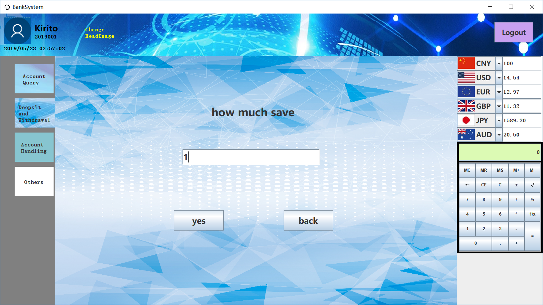

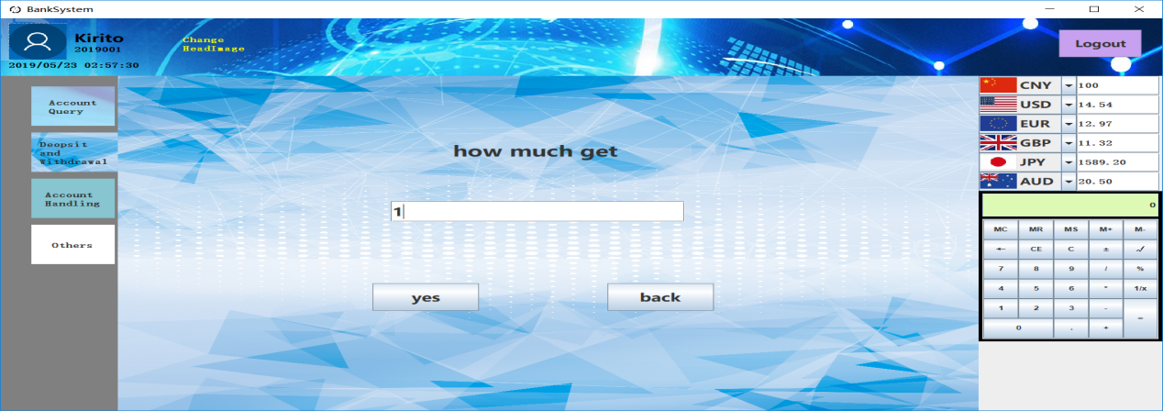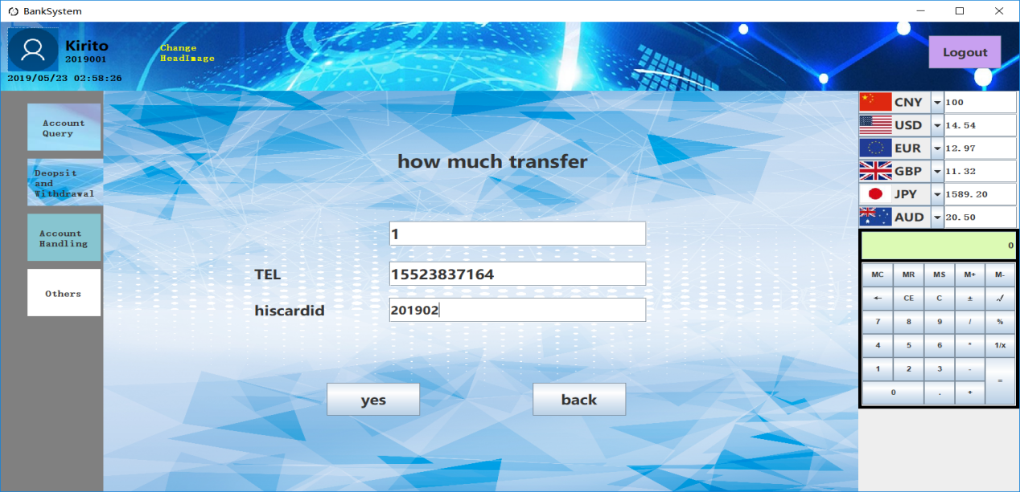

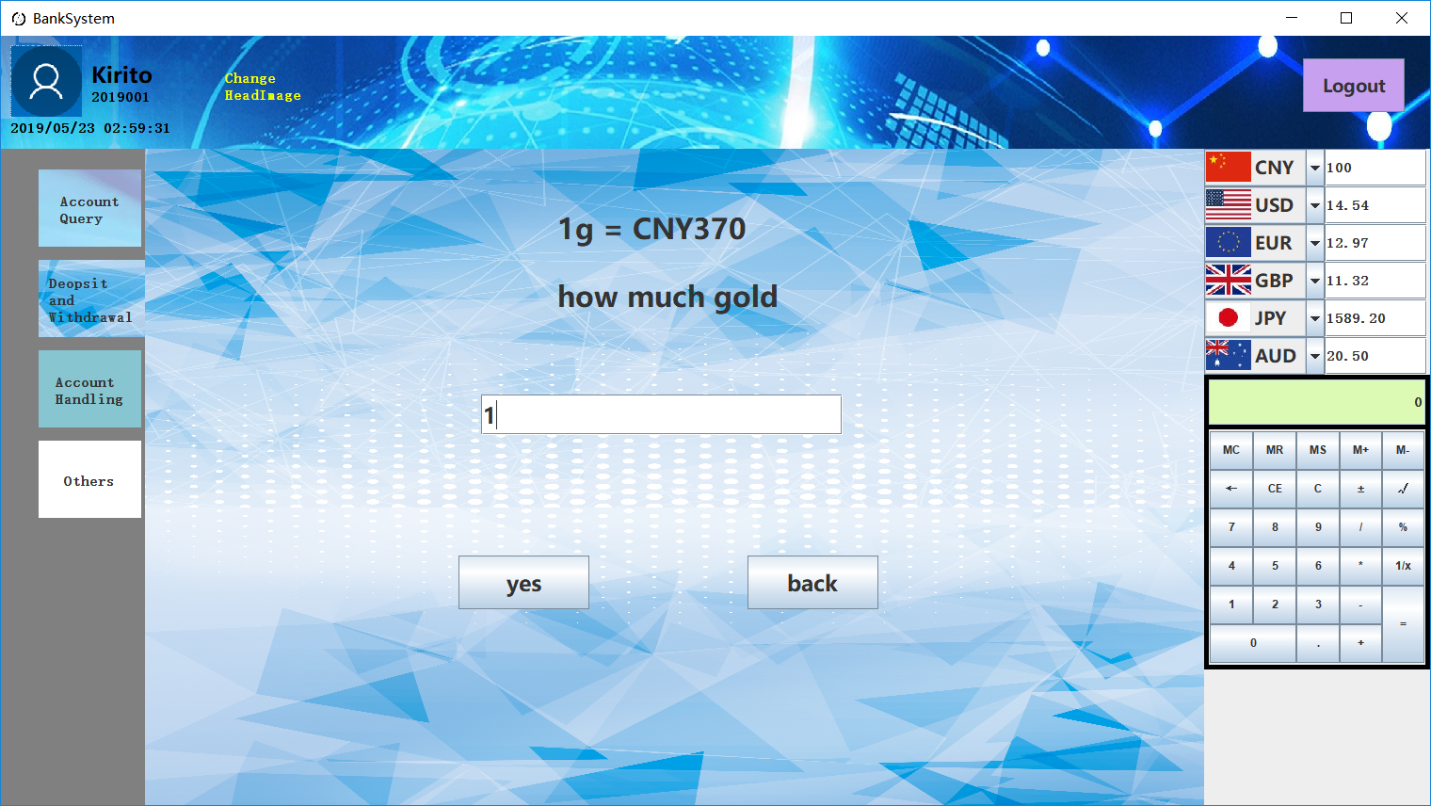

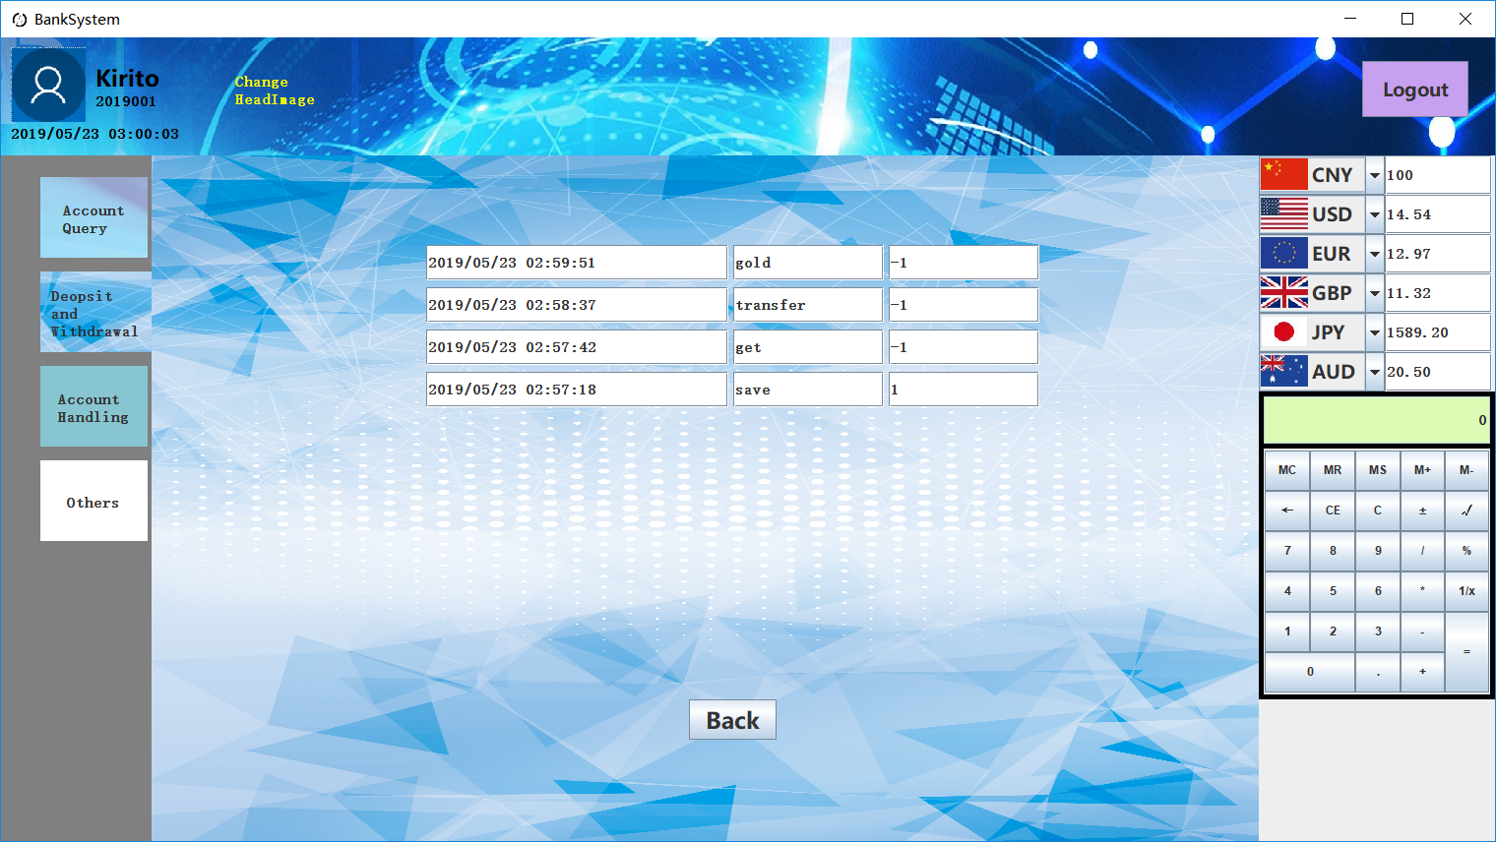

**//BankSystem.java**

**package com.tbt.banksystem;**

**import java.awt.BorderLayout;**

**import java.awt.Color;**

**import java.awt.Component;**

**import java.awt.Dimension;**

**import java.awt.Graphics;**

**import java.awt.GridLayout;**

**import java.awt.Image;**

**import java.awt.Insets;**

**import java.awt.event.ActionEvent;**

**import java.awt.event.ActionListener;**

**import java.awt.event.KeyAdapter;**

**import java.awt.event.KeyEvent;**

**import java.awt.event.MouseAdapter;**

**import java.awt.event.MouseEvent;**

**import java.io.IOException;**

**import java.io.InputStream;**

**import java.text.SimpleDateFormat;**

**import java.util.Calendar;**

**import java.util.Date;**

**import java.util.Timer;**

**import java.util.TimerTask;**

**import javax.imageio.ImageIO;**

**import javax.swing.ImageIcon;**

**import javax.swing.JButton;**

**import javax.swing.JComboBox;**

**import javax.swing.JFileChooser;**

**import javax.swing.JFrame;**

**import javax.swing.JLabel;**

**import javax.swing.JList;**

**import javax.swing.JPanel;**

**import javax.swing.JTextField;**

**import javax.swing.ListCellRenderer;**

**import javax.swing.SwingConstants;**

**import javax.swing.border.EmptyBorder;**

**import javax.swing.border.MatteBorder;**

**public class BankSystem extends JFrame{**

**private PageButton[] pagebtn;**

**private JPanel mainPanel[], topPanel, errorPanel;**

**private JLabel timeLabel, headLabel, errorLabel, errtimeLabel;**

**private int inPage = 0;**

**private String timeString, inLogin;**

**private JButton headButton;**

**private ExchangeRate rate[];**

**private ImageIcon icon = new ImageIcon(getClass().getResource("/com/tbt/banksystem/image/systemIcon.jpg"));**

**private ImageIcon head;**

**public BankSystem(String loginname, String loginnum) {**

**inLogin = loginnum;**

**setTitle("BankSystem");**

**setIconImage(icon.getImage());**

**setLayout(new BorderLayout());**

**topPanel = new JPanel() {**

**@Override**

**protected void paintComponent(Graphics g) {**

**ImageIcon img = new ImageIcon(getClass().getResource("/com/tbt/banksystem/image/toppanel_bg.jpg"));**

**g.drawImage(img.getImage(), 0, 0, getWidth(), 293, img.getImageObserver());**

**}**

**};**

**topPanel.setLayout(null);**

**topPanel.setPreferredSize(new Dimension(0, (int)(Start.height / 7.2)));**

**topPanel.setBackground(new Color(240, 220, 240));**

**headLabel = new JLabel();**

**headLabel.setBounds(10, 10, Start.width / 20, Start.width / 20);**

**iniHead();**

**topPanel.add(headLabel);**

**headButton = new JButton("<html>Change<br>HeadImage</html>");**

**headButton.setBorder(null);**

**headButton.setFocusPainted(false);**

**headButton.setFont(Start.useFont);**

**headButton.setForeground(Color.YELLOW);**

**headButton.setBounds(Start.width * 3 / 20, Start.height / 27, Start.width / 16, (int)(Start.height / 21.6));**

**headButton.setContentAreaFilled(false);**

**headButton.setMargin(new Insets(0, 0, 0, 0));**

**headButton.addMouseListener(new MouseAdapter() {**

**@Override**

**public void mouseClicked(MouseEvent e) {**

**super.mouseClicked(e);**

**JFileChooser fileChooser = new JFileChooser();**

**JFrame fileChooserFrame = new JFrame();**

**fileChooserFrame.setIconImage(icon.getImage());**

**if(fileChooser.showOpenDialog(fileChooserFrame) == JFileChooser.APPROVE_OPTION)**

**Start.uploadHead(fileChooser.getSelectedFile().getAbsolutePath(), inLogin);**

**iniHead();**

**}**

**@Override**

**public void mouseEntered(MouseEvent e) {**

**headButton.setText("<html><u>Change<br>HeadImage</u></html>");**

**}**

**@Override**

**public void mouseExited(MouseEvent e) {**

**headButton.setText("<html>Change<br>HeadImage</html>");**

**}**

**});**

**topPanel.add(headButton);**

**JLabel nameLabel = new JLabel(loginname);**

**nameLabel.setFont(Start.font30);**

**nameLabel.setForeground(Color.BLACK);**

**nameLabel.setBounds(Start.width / 16, Start.height / 36, Start.width / 15, Start.height / 27);**

**topPanel.add(nameLabel);**

**JLabel numLabel = new JLabel(loginnum);**

**numLabel.setFont(Start.useFont);**

**numLabel.setForeground(Color.BLACK);**

**numLabel.setBounds(Start.width / 16, Start.height / 15, Start.width / 15, Start.height / 54);**

**topPanel.add(numLabel);**

**timeLabel = new JLabel();**

**Timer timer = new Timer();**

**timer.scheduleAtFixedRate(new TimerTask() {**

**@Override**

**public void run() {**

**timeString = new SimpleDateFormat("yyyy/MM/dd HH:mm:ss").format(Calendar.getInstance().getTime());**

**timeLabel.setText(timeString);**

**}**

**}, new Date(), 1000);**

**timeLabel.setFont(Start.useFont);**

**timeLabel.setForeground(Color.BLACK);**

**timeLabel.setBounds(10, Start.height / 10, (int)(Start.width / 6.4), Start.height / 36);**

**topPanel.add(timeLabel);**

**JButton logoutBtn = new JButton("Logout");**

**logoutBtn.setBounds(Start.width - Start.width / 10, Start.height / 36, Start.height / 8, Start.height / 15);**

**logoutBtn.setFont(Start.font25);**

**logoutBtn.setBackground(new Color(200, 160, 240));**

**logoutBtn.addKeyListener(new KeyAdapter() {**

**@Override**

**public void keyPressed(KeyEvent e) {**

**if(e.getKeyCode() == KeyEvent.VK_ENTER)**

**Start.logOut();**

**}**

**});**

**logoutBtn.addMouseListener(new MouseAdapter() {**

**@Override**

**public void mouseClicked(MouseEvent e) {**

**Start.logOut();**

**}**

**});**

**topPanel.add(logoutBtn);**

**JPanel pagePanel = new JPanel();**

**pagePanel.setLayout(null);**

**pagePanel.setPreferredSize(new Dimension(Start.width / 10, 0));**

**pagePanel.setBackground(Color.GRAY);**

**pagebtn = new PageButton[4];**

**for(int i = 0; i < 4; i++)**

**pagebtn[i] = new PageButton(i);**

**pagebtn[0].getButton().setText("<html>Account<br>Query</html>");**

**pagebtn[1].getButton().setText("<html>Deopsit<br>and<br>Withdrawal</html>");**

**pagebtn[2].getButton().setText("<html>Account<br>Handling</html>");**

**pagebtn[3].getButton().setText("<html>Others</html>");**

**pagebtn[0].getButton().setIcon(new ImageIcon(getClass().getResource("/com/tbt/banksystem/image/accountquery_btn.jpg")));**

**pagebtn[1].getButton().setIcon(new ImageIcon(getClass().getResource("/com/tbt/banksystem/image/deopsitandwithdrawal_btn.jpg")));**

**pagebtn[2].getButton().setIcon(new ImageIcon(getClass().getResource("/com/tbt/banksystem/image/accounthandling_btn.jpg")));**

**pagebtn[3].getButton().setIcon(new ImageIcon(getClass().getResource("/com/tbt/banksystem/image/zxgsbb_btn.jpg")));**

**pagebtn[0].pageIn();**

**for(int i = 0; i < 4; i++)**

**pagePanel.add(pagebtn[i].getButton());**

**JPanel rightPanel = new JPanel(new BorderLayout());**

**rightPanel.setBorder(new EmptyBorder(0, 0, Start.height / 6, 0));**

**rightPanel.setPreferredSize(new Dimension((int)(Start.width / 6.4), 0));**

**JPanel exchangeratePanel = new JPanel();**

**exchangeratePanel.setLayout(new GridLayout(6, 1));**

**exchangeratePanel.setPreferredSize(new Dimension(0, (int)(Start.width / 6.4)));**

**rate = new ExchangeRate[6];**

**for(int i = 0; i < 6; i++) {**

**rate[i] = new ExchangeRate(i);**

**exchangeratePanel.add(rate[i]);**

**}**

**rightPanel.add(exchangeratePanel, BorderLayout.NORTH);**

**rateRefresh(0);**

**Calculator calculator = new Calculator();**

**calculator.setBackground(Color.BLACK);**

**rightPanel.add(calculator, BorderLayout.CENTER);**

**mainPanel = new JPanel[4];**

**mainPanel[0] = new AccountQueryPanel();**

**mainPanel[1] = new DeopsitWithdrawalPanel();**

**mainPanel[2] = new AccountHandlingPanel();**

**mainPanel[3] = new ZxgsbbPanel();**

**errorLabel = new JLabel();**

**errorLabel.setFont(Start.font30);**

**errorLabel.setForeground(Color.RED);**

**errorLabel.setVerticalAlignment(JLabel.CENTER);**

**errorLabel.setHorizontalAlignment(JLabel.CENTER);**

**errtimeLabel = new JLabel();**

**errtimeLabel.setFont(Start.useFont);**

**errtimeLabel.setForeground(Color.BLUE);**

**errtimeLabel.setHorizontalAlignment(JLabel.CENTER);**

**errtimeLabel.setPreferredSize(new Dimension(0, Start.height / 12));**

**errorPanel = new JPanel(new BorderLayout());**

**errorPanel.setBackground(Color.YELLOW);**

**errorPanel.setBounds(Start.width / 5, Start.height / 6, Start.width / 3, Start.height / 3);**

**errorPanel.add(errorLabel, BorderLayout.CENTER);**

**errorPanel.add(errtimeLabel, BorderLayout.SOUTH);**

**add(topPanel, BorderLayout.NORTH);**

**add(pagePanel, BorderLayout.WEST);**

**add(rightPanel, BorderLayout.EAST);**

**add(mainPanel[0], BorderLayout.CENTER);**

**setSize(Start.width, Start.height);**

**setExtendedState(MAXIMIZED_BOTH);**

**setDefaultCloseOperation(EXIT_ON_CLOSE);**

**setVisible(true);**

**}**

**private void changePage(int pagenum) {**

**pagebtn[inPage].pageOut();**

**pagebtn[pagenum].pageIn();**

**remove(mainPanel[inPage]);**

**add(mainPanel[pagenum], BorderLayout.CENTER);**

**inPage = pagenum;**

**repaint();**

**}**

**public void errorMessage(String error) {**

**mainPanel[inPage].remove(errorPanel);**

**errorLabel.setText(error);**

**final Timer t = new Timer();**

**t.schedule(new TimerTask() {**

**private int s = 5;**

**@Override**

**public void run() {**

**errtimeLabel.setText("Automatic return in " + s + " Second(s)");**

**if(s == 0) {**

**mainPanel[inPage].remove(errorPanel);**

**repaint();**

**if(inPage == 3) {**

**((ZxgsbbPanel)mainPanel[3]).panel[((ZxgsbbPanel)mainPanel[3]).inPanel].nextButton.setVisible(true);**

**}**

**cancel();**

**}**

**s--;**

**}**

**}, new Date(), 1000);**

**errorLabel.addMouseListener(new MouseAdapter() {**

**@Override**

**public void mouseClicked(MouseEvent e) {**

**mainPanel[inPage].remove(errorPanel);**

**t.cancel();**

**repaint();**

**if(inPage == 3) {**

**((ZxgsbbPanel)mainPanel[3]).panel[((ZxgsbbPanel)mainPanel[3]).inPanel].nextButton.setVisible(true);**

**}**

**}**

**});**

**mainPanel[inPage].add(errorPanel);**

**errorPanel.requestFocus();**

**mainPanel[inPage].setComponentZOrder(errorPanel, 0);**

**repaint();**

**}**

**private void iniHead() {**

**InputStream is = Start.getHead(inLogin);**

**if(is != null) {**

**try {**

**Image image = ImageIO.read(is);**

**head = new ImageIcon(image);**

**} catch (IOException e) {**

**e.printStackTrace();**

**}**

**}**

**else**

**head = new ImageIcon(getClass().getResource("/com/tbt/banksystem/image/defaulthead.png"));**

**head.setImage(head.getImage().getScaledInstance(Start.width / 20, Start.width / 20, Image.SCALE_DEFAULT));**

**headLabel.setIcon(head);**

**repaint();**

**}**

**public void rateRefresh(int n) {**

**double changeRate[][] = {**

**{1, 0.1454, 0.12971, 0.11321, 15.892, 0.205},**

**{6.8746, 1, 0.8922, 0.77879, 109.456, 1.4473},**

**{7.7057, 1.1205, 1, 0.87288, 122.667, 1.62197},**

**{8.8282, 1.28395, 1.1457, 1, 140.538, 1.85817},**

**{0.06277, 0.009133, 0.0081514, 0.00711, 1, 0.013215},**

**{4.7505, 0.69102, 0.6164, 0.538, 75.64, 1}**

**};**

**double k = 0;**

**try {**

**k = Double.parseDouble(rate[n].textField.getText());**

**}catch (NumberFormatException e) {**

**}**

**for(int i = 0; i < 6; i++) {**

**if(i == n)**

**continue;**

**else {**

**String s = "" + k * changeRate[rate[n].comboBox.getSelectedIndex()][rate[i].comboBox.getSelectedIndex()];**

**rate[i].textField.setText(point2(s));**

**}**

**repaint();**

**}**

**}**

**public String point2(String NStr) {**

**for(int i = 0; i < NStr.length(); i++) {**

**if(NStr.charAt(i) == '.') {**

**if(NStr.length() > i + 2)**

**return NStr.substring(0, i + 3);**

**else {**

**NStr += "00";**

**i--;**

**}**

**}**

**}**

**return NStr;**

**}**

**class PageButton {**

**private JButton pagebtn;**

**private int pagenum;**

**public PageButton(final int n) {**

**pagenum = n;**

**pagebtn = new JButton();**

**pagebtn.setFont(Start.useFont);**

**pagebtn.setContentAreaFilled(false);**

**pagebtn.setHorizontalTextPosition(SwingConstants.CENTER);**

**pagebtn.setBorder(new MatteBorder(2, 2, 2, 4, Color.GRAY));**

**pagebtn.setBounds(Start.width / 40, n * Start.height / 9 + 20, Start.width * 3 / 40, Start.height / 10);**

**pagebtn.addMouseListener(new MouseAdapter() {**

**@Override**

**public void mouseClicked(MouseEvent e) {**

**changePage(n);**

**}**

**});**

**}**

**public JButton getButton() {**

**return pagebtn;**

**}**

**public int getPagenum() {**

**return pagenum;**

**}**

**public void pageIn() {**

**pagebtn.setBorder(new MatteBorder(2, 2, 2, 0, Color.GRAY));**

**}**

**public void pageOut() {**

**pagebtn.setBorder(new MatteBorder(2, 2, 2, 4, Color.GRAY));**

**}**

**}**

**class ExchangeRate extends JPanel{**

**public int row;**

**public JComboBox<JLabel> comboBox;**

**public JTextField textField;**

**public ExchangeRate(int i) {**

**row = i;**

**setLayout(null);**

**setPreferredSize(new Dimension((int)(Start.width / 6.4), (int)(Start.width / 38.4)));**

**String Str[] = {"CNY", "USD", "EUR", "GBP", "JPY", "AUD"};**

**JLabel l[] = new JLabel[6];**

**for(int k = 0; k < 6; k++) {**

**ImageIcon flag = new ImageIcon(getClass().getResource("/com/tbt/banksystem/image/flag" + k + ".jpg"));**

**flag.setImage(flag.getImage().getScaledInstance(Start.width / 32, Start.height / 27, Image.SCALE_DEFAULT));**

**l[k] = new JLabel(Str[k], flag, JLabel.LEFT);**

**l[k].setFont(Start.font25);**

**}**

**comboBox = new JComboBox<JLabel>(l);**

**comboBox.setRenderer(new ListCellRenderer<JLabel>() {**

**@Override**

**public Component getListCellRendererComponent(JList<? extends JLabel> arg0, JLabel arg1, int arg2,**

**boolean arg3, boolean arg4) {**

**return arg1;**

**}**

**});**

**comboBox.setSelectedIndex(i);**

**comboBox.setBounds(0, 0, (int)(Start.width / 12), (int)(Start.width / 38.4));**

**comboBox.setFont(Start.font25);**

**ActionListener listener = new ActionListener() {**

**@Override**

**public void actionPerformed(ActionEvent e) {**

**rateRefresh(row);**

**}**

**};**

**comboBox.addActionListener(listener);**

**add(comboBox);**

**textField = new JTextField("100");**

**textField.setBounds((int)(Start.width / 12), 0, (int)(Start.width / 14), (int)(Start.width / 38.4));**

**textField.setFont(Start.useFont);**

**textField.addActionListener(listener);**

**add(textField);**

**}**

**}**

**}**

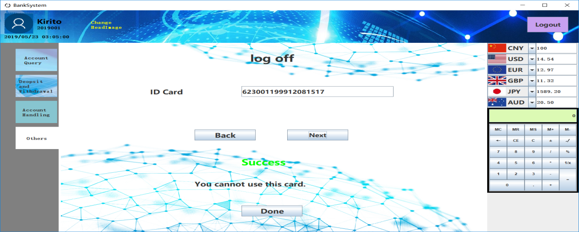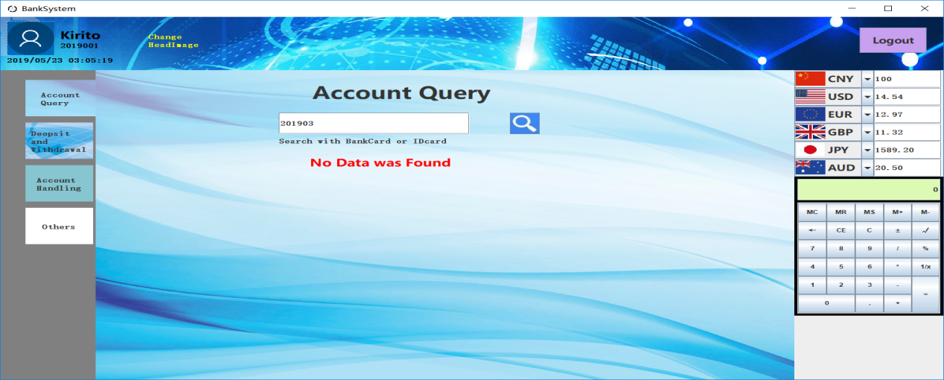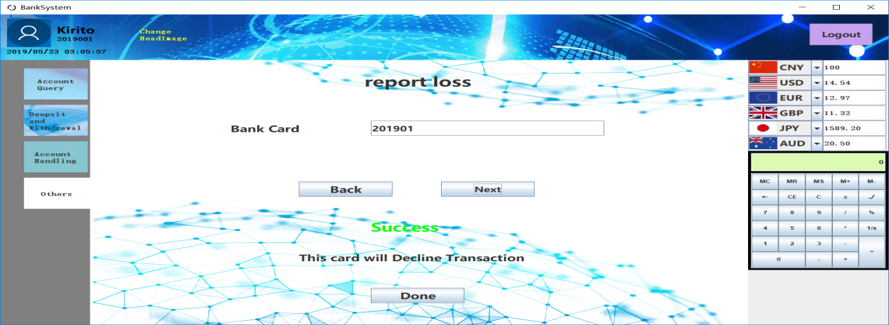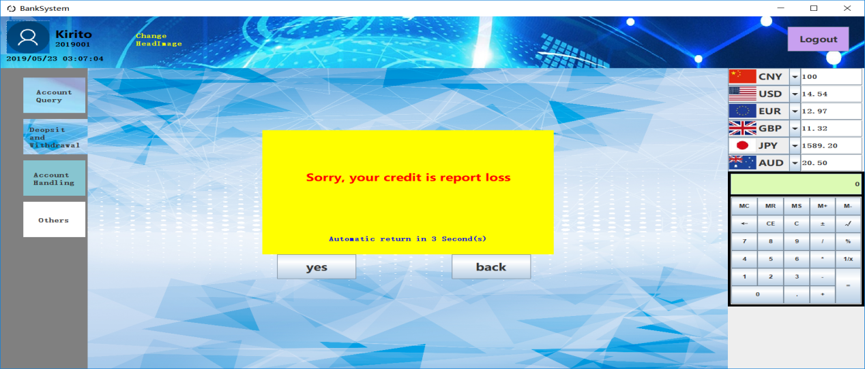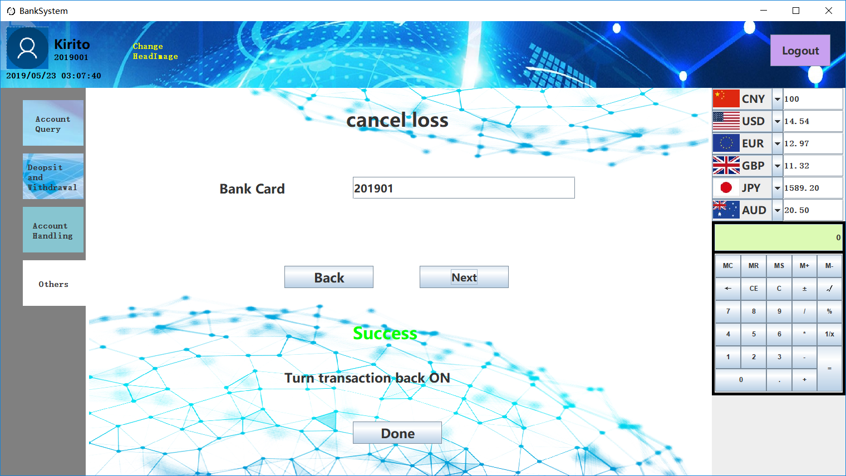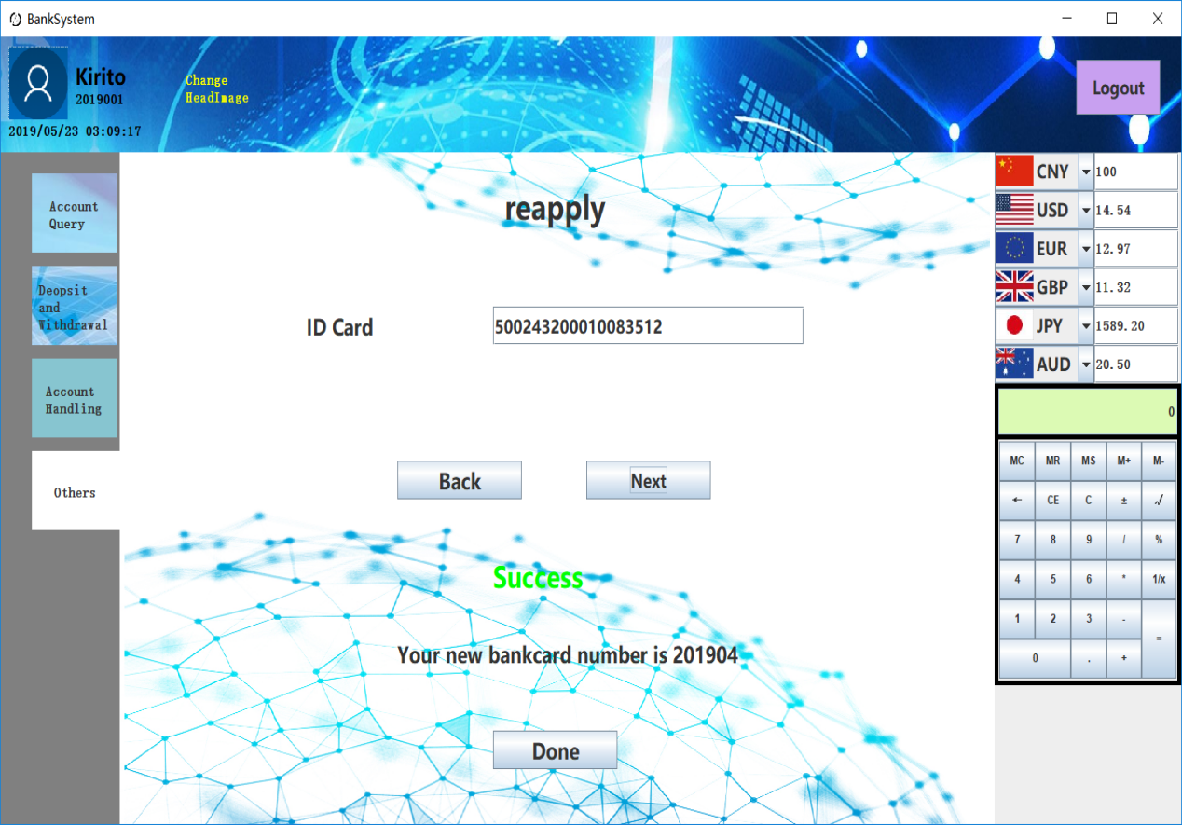

**//AccountQueryPanel.java**

**package com.tbt.banksystem;**

**import java.awt.BorderLayout;**

**import java.awt.Color;**

**import java.awt.Component;**

**import java.awt.Dimension;**

**import java.awt.FlowLayout;**

**import java.awt.Font;**

**import java.awt.Graphics;**

**import java.awt.event.KeyAdapter;**

**import java.awt.event.KeyEvent;**

**import java.awt.event.MouseAdapter;**

**import java.awt.event.MouseEvent;**

**import java.sql.ResultSet;**

**import java.sql.SQLException;**

**import java.util.Vector;**

**import javax.swing.ImageIcon;**

**import javax.swing.JButton;**

**import javax.swing.JLabel;**

**import javax.swing.JList;**

**import javax.swing.JPanel;**

**import javax.swing.JTextField;**

**import javax.swing.ListCellRenderer;**

**public class AccountQueryPanel extends JPanel{**

**private JPanel searchPanel, infoPanel;**

**private JTextField searchField;**

**private JList<Row> infoList;**

**private JLabel infoLabel;**

**private cardPanel card;**

**public AccountQueryPanel() {**

**setLayout(new BorderLayout());**

**searchPanel = new JPanel(null);**

**searchPanel.setPreferredSize(new Dimension(0, (int)(Start.height / 4.5)));**

**searchPanel.setOpaque(false);**

**infoPanel = new JPanel(new FlowLayout(FlowLayout.RIGHT, Start.width / 20, 0));**

**infoPanel.setOpaque(false);**

**JLabel sertchTitleLabel = new JLabel("Account Query");**

**sertchTitleLabel.setFont(Start.font50);**

**sertchTitleLabel.setBounds((int)(Start.width / 4.4), Start.height / 50, Start.width / 4, (int)(Start.height / 13.5));**

**searchPanel.add(sertchTitleLabel);**

**searchField = new JTextField();**

**searchField.setFont(Start.useFont);**

**searchField.setBounds((int)(Start.width / 5.2), Start.height / 9, Start.width / 5, Start.height / 18);**

**searchField.addKeyListener(new KeyAdapter() {**

**@Override**

**public void keyPressed(KeyEvent e) {**

**if(e.getKeyCode() == KeyEvent.VK_ENTER)**

**search();**

**}**

**});**

**searchPanel.add(searchField);**

**JButton sertchButton = new JButton(new ImageIcon(getClass().getResource("/com/tbt/banksystem/image/accountsertch_btn.jpg")));**

**sertchButton.setFont(Start.useFont);**

**sertchButton.setBounds((int)(Start.width / 2.3), Start.height / 9, Start.height / 18, Start.height / 18);**

**sertchButton.addMouseListener(new MouseAdapter() {**

**@Override**

**public void mouseClicked(MouseEvent e) {**

**search();**

**}**

**});**

**searchPanel.add(sertchButton);**

**JLabel searchts = new JLabel("Search with BankCard or IDcard");**

**searchts.setFont(Start.useFont);**

**searchts.setBounds((int)(Start.width / 5.2), Start.height / 6, Start.width / 5, Start.height / 27);**

**searchPanel.add(searchts);**

**infoList = new JList<Row>();**

**infoLabel = new JLabel("No Data was Found");**

**infoLabel.setFont(Start.font30);**

**infoLabel.setForeground(Color.RED);**

**infoLabel.setHorizontalAlignment(JLabel.CENTER);**

**infoLabel.setVerticalAlignment(JLabel.NORTH);**

**infoLabel.setPreferredSize(new Dimension((int)(Start.width / 1.3), Start.height / 2));**

**card = new cardPanel();**

**card.setPreferredSize(new Dimension(Start.width / 5, (int)(Start.height / 4.2)));**

**add(searchPanel, BorderLayout.NORTH);**

**add(infoPanel, BorderLayout.CENTER);**

**}**

**private void search() {**

**infoPanel.remove(card);**

**infoPanel.remove(infoList);**

**infoPanel.remove(infoLabel);**

**Vector<Row> rows = new Vector<Row>();**

**ResultSet res = Start.getUserres(3, searchField.getText());**

**if(res != null) {**

**for(int i = 1; i < 11; i++) {**

**Row r = new Row();**

**try {**

**r.label.setText(res.getMetaData().getColumnName(i));**

**r.field.setText(res.getString(i));**

**} catch (SQLException e1) {**

**e1.printStackTrace();**

**}**

**rows.add(r);**

**}**

**infoList = new JList<Row>(rows);**

**infoList.setOpaque(false);**

**infoList.setCellRenderer(new ListCellRenderer<Row>() {**

**@Override**

**public Component getListCellRendererComponent(JList<? extends Row> list, Row value, int index,**

**boolean isSelected, boolean cellHasFocus) {**

**return value;**

**}**

**});**

**infoPanel.add(infoList);**

**card.bcnum.setText(searchField.getText());**

**try {**

**card.setBalance(res.getString(8));**

**} catch (SQLException e) {**

**e.printStackTrace();**

**}**

**infoPanel.add(card);**

**}**

**else {**

**infoPanel.add(infoLabel);**

**}**

**repaint();**

**}**

**@Override**

**protected void paintComponent(Graphics g) {**

**super.paintComponent(g);**

**ImageIcon bg = new ImageIcon(getClass().getResource("/com/tbt/banksystem/image/accountquery_bg.jpg"));**

**g.drawImage(bg.getImage(), 0, 0, getWidth(), getHeight(), bg.getImageObserver());**

**}**

**class Row extends JPanel{**

**public JLabel label;**

**public JTextField field;**

**public Row() {**

**setOpaque(false);**

**label = new JLabel();**

**label.setFont(Start.useFont);**

**label.setPreferredSize(new Dimension(Start.width / 9, Start.height / 24));**

**field = new JTextField();**

**field.setFont(Start.useFont);**

**field.setPreferredSize(new Dimension(Start.width / 9, Start.height / 24));**

**add(label);**

**add(field);**

**}**

**}**

**class cardPanel extends JPanel{**

**public JLabel bcnum, balance;**

**public cardPanel() {**

**setLayout(null);**

**setPreferredSize(new Dimension(Start.width / 5, (int)(Start.height / 4.2)));**

**bcnum = new JLabel();**

**bcnum.setFont(Start.font25);**

**bcnum.setBounds((int)(Start.width / 12.8), Start.height / 6, Start.width / 10, Start.height / 20);**

**add(bcnum);**

**balance = new JLabel();**

**balance.setFont(new Font("宋体", Font.BOLD, Start.width / 80));**

**balance.setBounds((int)(Start.width / 19.2), (int)(Start.height / 13.5), (int)(Start.width / 6.4), Start.height / 20);**

**add(balance);**

**}**

**public void setBalance(String balance) {**

**this.balance.setText("Balance: " + balance);**

**}**

**@Override**

**protected void paintComponent(Graphics g) {**

**ImageIcon img = new ImageIcon(getClass().getResource("/com/tbt/banksystem/image/bankcard.jpg"));**

**g.drawImage(img.getImage(), 0, 0, getWidth(), getHeight(), img.getImageObserver());**

**}**

**}**

**}**

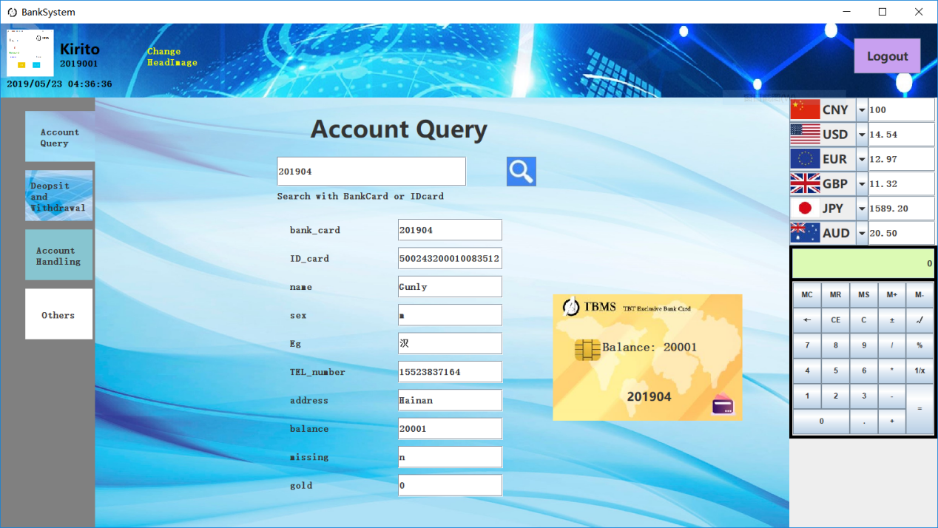

**//DeopsitWithdrawalPanel.java**

**package com.tbt.banksystem;**

**import java.awt.BorderLayout;**

**import java.awt.Component;**

**import java.awt.Dimension;**

**import java.awt.Graphics;**

**import java.awt.event.KeyAdapter;**

**import java.awt.event.KeyEvent;**

**import java.awt.event.MouseAdapter;**

**import java.awt.event.MouseEvent;**

**import java.sql.ResultSet;**

**import java.sql.SQLException;**

**import java.util.Vector;**

**import javax.swing.ImageIcon;**

**import javax.swing.JButton;**

**import javax.swing.JLabel;**

**import javax.swing.JList;**

**import javax.swing.JPanel;**

**import javax.swing.JPasswordField;**

**import javax.swing.JTextField;**

**import javax.swing.ListCellRenderer;**

**import javax.swing.border.EmptyBorder;**

**public class DeopsitWithdrawalPanel extends JPanel{**

**private JPanel p1,p2,p3,p4,p6,p7,p8;**

**private String bankcard;**

**private JTextField t1;**

**private JTextField t2;**

**private JTextField t3;**

**private JTextField t4;**

**private JTextField t5;**

**private JTextField t6;**

**private JPasswordField t7;**

**private JLabel l2;**

**private JLabel l4;**

**private JLabel l7;**

**private JLabel l10;**

**private Component t8;**

**private JList<HistoryRow> history;**

**public DeopsitWithdrawalPanel()**

**{**

**setLayout(null);**

**panel1();**

**panel2();**

**panel4();**

**panel6();**

**panel7();**

**panel8();**

**}**

**public void panel1()**

**{**

**p1= new JPanel();**

**p1.setLayout(null);**

**p1.setOpaque(false);**

**p1.setBounds(0, 0, (int)(Start.width / 1.3), (int)(Start.height / 1.2));**

**final JButton b1= new JButton("save");**

**b1.setFont(Start.font30);**

**b1.setBounds((int)(Start.width / 4.2), (int)(Start.height / 4.9), Start.width / 10, Start.height / 12);**

**b1.addMouseListener(new MouseAdapter(){**

**public void mouseClicked(MouseEvent e)**

**{**

**if(e.getSource()==b1)**

**{**

**l2.setVisible(false);**

**t1.setText(null);**

**remove(p1);**

**add(p2);**

**repaint();**

**validate();**

**}**

**}**

**});**

**final JButton b2= new JButton("get");**

**b2.setFont(Start.font30);**

**b2.setBounds((int)(Start.width/2.6), (int)(Start.height / 4.9), Start.width / 10, Start.height / 12);**

**b2.addMouseListener(new MouseAdapter(){**

**public void mouseClicked(MouseEvent ex)**

**{**

**if(ex.getSource()==b2)**

**{**

**l4.setVisible(false);**

**t2.setText(null);**

**remove(p1);**

**add(p4);**

**repaint();**

**validate();**

**}**

**}**

**});**

**final JButton b3= new JButton("transfer");**

**b3.setBounds((int)(Start.width / 4.2), (int)(Start.height / 2.1), Start.width / 10, Start.height / 12);**

**b3.setFont(Start.font30);**

**b3.addMouseListener(new MouseAdapter(){**

**public void mouseClicked(MouseEvent exe)**

**{**

**if(exe.getSource()==b3)**

**{**

**l7.setVisible(false);**

**t3.setText(null);**

**t4.setText(null);**

**remove(p1);**

**add(p6);**

**repaint();**

**validate();**

**}**

**}**

**});**

**final JButton b4= new JButton("gold");**

**b4.setBounds((int)(Start.width/2.6), (int)(Start.height / 2.1), Start.width / 10, Start.height / 12);**

**b4.setFont(Start.font30);**

**b4.addMouseListener(new MouseAdapter(){**

**public void mouseClicked(MouseEvent exe)**

**{**

**if(exe.getSource()==b4)**

**{**

**l10.setVisible(false);**

**t5.setText(null);**

**remove(p1);**

**add(p7);**

**repaint();**

**validate();**

**}**

**}**

**});**

**final JButton b5= new JButton("back");**

**b5.setBounds(Start.height,(int)(Start.height / 1.5), Start.width / 10, Start.height / 12);**

**b5.setFont(Start.font30);**

**b5.addMouseListener(new MouseAdapter(){**

**public void mouseClicked(MouseEvent exe)**

**{**

**if(exe.getSource()==b5)**

**{**

**t6.setText(null);**

**t7.setText(null);**

**remove(p1);**

**add(p8);**

**repaint();**

**validate();**

**}**

**}**

**});**

**final JButton b6= new JButton("deal");**

**b6.setBounds((int)(Start.width/3.2), Start.height/3, Start.width / 10, Start.height / 12);**

**b6.setFont(Start.font30);**

**b6.addMouseListener(new MouseAdapter(){**

**public void mouseClicked(MouseEvent exe)**

**{**

**if(exe.getSource()==b6)**

**{**

**remove(p1);**

**panel3();**

**add(p3);**

**repaint();**

**validate();**

**}**

**}**

**});**

**p1.add(b1);**

**p1.add(b2);**

**p1.add(b3);**

**p1.add(b4);**

**p1.add(b5);**

**p1.add(b6);**

**}**

**public void panel2()**

**{**

**p2= new JPanel();**

**p2.setLayout(null);**

**p2.setOpaque(false);**

**p2.setBounds(0, 0, (int)(Start.width / 1.3), (int)(Start.height / 1.2));**

**JLabel l1= new JLabel("how much save");**

**l1.setOpaque(false);**

**l1.setFont(Start.font40);**

**l1.setBounds((int)(Start.width / 3.5), (int)(Start.height / 7.2), Start.width / 5, Start.height / 12);**

**l2= new JLabel("success saving");**

**l2.setOpaque(false);**

**l2.setFont(Start.font40);**

**l2.setBounds((int)(Start.width / 3.5), (int)(Start.height / 1.7), Start.width / 5, Start.height / 12);**

**l2.setVisible(false);**

**t1= new JTextField(16);**

**t1.setFont(Start.font30);**

**t1.setBounds((int)(Start.width/4.3), (int)(Start.height / 3.3),Start.width / 4,Start.height / 20);**

**final JButton b1= new JButton("yes");**

**b1.setFont(Start.font30);**

**b1.setBounds((int)(Start.width/4.6),Start.height/2,Start.width / 11,Start.height / 15);**

**b1.addMouseListener(new MouseAdapter(){**

**public void mouseClicked(MouseEvent e)**

**{**

**int i = Start.moneyadd(bankcard, t1.getText(), "save");**

**if(i == 0) {**

**l2.setVisible(true);**

**repaint();**

**validate();**

**}**

**else {**

**error("Save money", i);**

**}**

**}**

**});**

**final JButton b2= new JButton("back");**

**b2.setFont(Start.font30);**

**b2.setBounds((int)(Start.width/2.4),Start.height/2,Start.width / 11,Start.height / 15);**

**b2.addMouseListener(new MouseAdapter(){**

**public void mouseClicked(MouseEvent ex)**

**{**

**if(ex.getSource()==b2)**

**{**

**remove(p2);**

**add(p1);**

**repaint();**

**validate();**

**}**

**}**

**});**

**p2.add(l1);**

**p2.add(l2);**

**p2.add(t1);**

**p2.add(b1);**

**p2.add(b2);**

**}**

**public void panel3()**

**{**

**p3 = new JPanel(new BorderLayout());**

**p3.setBounds(0, 0, (int)(Start.width / 1.3), (int)(Start.height / 1.2));**

**p3.setBorder(new EmptyBorder(Start.height/10, 0, 0, 0));**

**p3.setOpaque(false);**

**JButton b1 = new JButton("Back");**

**b1.setBounds(0, 0, Start.width / 20,Start.height / 20);**

**b1.setFont(Start.font30);**

**b1.addMouseListener(new MouseAdapter() {**

**@Override**

**public void mouseClicked(MouseEvent e) {**

**remove(p3);**

**add(p1);**

**repaint();**

**}**

**});**

**JPanel panel = new JPanel();**

**panel.setOpaque(false);**

**panel.setPreferredSize(new Dimension(0, Start.height/5));**

**panel.add(b1);**

**p3.add(panel, BorderLayout.SOUTH);**

**Vector<HistoryRow> rows = new Vector<HistoryRow>();**

**ResultSet res = Start.getHistory(bankcard);**

**if(res != null) {**

**try {**

**for(int i = 0; i < 10 && res.next(); i++) {**

**HistoryRow r = new HistoryRow();**

**r.t1.setText(res.getString(2));**

**r.t2.setText(res.getString(3));**

**r.t3.setText(res.getString(4));**

**rows.add(r);**

**}**

**} catch (SQLException e1) {**

**e1.printStackTrace();**

**}**

**}**

**history = new JList<HistoryRow>(rows);**

**history.setCellRenderer(new ListCellRenderer<HistoryRow>() {**

**@Override**

**public Component getListCellRendererComponent(JList<? extends HistoryRow> arg0, HistoryRow arg1,**

**int arg2, boolean arg3, boolean arg4) {**

**return arg1;**

**}**

**});**

**history.setOpaque(false);**

**p3.add(history, BorderLayout.CENTER);**

**}**

**public void panel4()**

**{**

**p4= new JPanel();**

**p4.setLayout(null);**

**p4.setOpaque(false);**

**p4.setBounds(0, 0, (int)(Start.width / 1.3), (int)(Start.height / 1.2));**

**JLabel l3= new JLabel("how much get");**

**l3.setOpaque(false);**

**l3.setFont(Start.font40);**

**l3.setBounds((int)(Start.width / 3.5), (int)(Start.height / 7.2), Start.width / 5, Start.height / 12);**

**l4= new JLabel("success getting");**

**l4.setOpaque(false);**

**l4.setFont(Start.font40);**

**l4.setBounds((int)(Start.width / 3.5), (int)(Start.height / 1.7), Start.width / 5, Start.height / 12);**

**l4.setVisible(false);**

**t2= new JTextField(7);**

**t2.setFont(Start.font30);**

**t2.setBounds((int)(Start.width/4.3), (int)(Start.height / 3.3),Start.width / 4,Start.height / 20);**

**final JButton b1= new JButton("yes");**

**b1.setFont(Start.font30);**

**b1.setBounds((int)(Start.width/4.6),Start.height/2,Start.width / 11,Start.height / 15);**

**b1.addMouseListener(new MouseAdapter(){**

**public void mouseClicked(MouseEvent e)**

**{**

**int i = Start.moneyadd(bankcard, "-" + t2.getText(), "get");**

**if(i == 0)**

**{**

**l4.setVisible(true);**

**repaint();**

**validate();**

**}**

**else {**

**error("Get money", i);**

**}**

**}**

**});**

**final JButton b2= new JButton("back");**

**b2.setFont(Start.font30);**

**b2.setBounds((int)(Start.width/2.4),Start.height/2,Start.width / 11,Start.height / 15);**

**b2.addMouseListener(new MouseAdapter(){**

**public void mouseClicked(MouseEvent ex)**

**{**

**if(ex.getSource()==b2)**

**{**

**remove(p4);**

**add(p1);**

**repaint();**

**validate();**

**}**

**}**

**});**

**p4.add(l3);**

**p4.add(l4);**

**p4.add(t2);**

**p4.add(b1);**

**p4.add(b2);**

**}**

**public void panel6()**

**{**

**p6= new JPanel();**

**p6.setLayout(null);**

**p6.setOpaque(false);**

**p6.setBounds(0, 0, (int)(Start.width / 1.3), (int)(Start.height / 1.2));**

**JLabel l5= new JLabel("how much transfer");**

**l5.setOpaque(false);**

**l5.setFont(Start.font40);**

**l5.setBounds((int)(Start.width / 3.5), Start.height/10, (int)(Start.width / 4.1), Start.height/12);**

**t3= new JTextField(16);**

**t3.setFont(Start.font30);**

**t3.setBounds((int)(Start.width/3.6), (int)(Start.height / 3.8), Start.width / 4,Start.height / 20);**

**JLabel l6= new JLabel("hiscardid");**

**l6.setOpaque(false);**

**l6.setFont(Start.font30);**

**l6.setBounds((int)(Start.width/6.8),(int)(Start.height/2.4),Start.width/10,Start.height/20);**

**l7= new JLabel("success transforing");**

**l7.setOpaque(false);**

**l7.setFont(Start.font40);**

**l7.setBounds((int)(Start.width / 3.5), (int)(Start.height / 1.5), Start.width / 5, Start.height / 12);**

**l7.setVisible(false);**

**JLabel l13= new JLabel("TEL");**

**l13.setOpaque(false);**

**l13.setFont(Start.font30);**

**l13.setBounds((int)(Start.width/6.8),(int)(Start.height / 2.9),Start.width/10,Start.height/20);**

**t8= new JTextField(13);**

**t8.setFont(Start.font30);**

**t8.setBounds((int)(Start.width/3.6), (int)(Start.height / 2.9), Start.width / 4,Start.height / 20);**

**t4= new JTextField(15);**

**t4.setFont(Start.font25);**

**t4.setBounds((int)(Start.width/3.6), (int)(Start.height/2.4), Start.width / 4,Start.height / 20);**

**final JButton b1= new JButton("yes");**

**b1.setFont(Start.font30);**

**b1.setBounds((int)(Start.width/4.6),(int)(Start.height / 1.7),Start.width / 11,Start.height / 15);**

**b1.addMouseListener(new MouseAdapter(){**

**public void mouseClicked(MouseEvent e)**

**{**

**int i = Start.trans(bankcard, t4.getText(), t3.getText());**

**if(i == 0) {**

**l7.setVisible(true);**

**repaint();**

**validate();**

**}**

**else {**

**error("Transfer", i);**

**}**

**}**

**});**

**final JButton b2= new JButton("back");**

**b2.setFont(Start.font30);**

**b2.setBounds((int)(Start.width/2.4),(int)(Start.height / 1.7),Start.width / 11,Start.height / 15);**

**b2.addMouseListener(new MouseAdapter(){**

**public void mouseClicked(MouseEvent ex)**

**{**

**if(ex.getSource()==b2)**

**{**

**remove(p6);**

**add(p1);**

**repaint();**

**validate();**

**}**

**}**

**});**

**p6.add(l5);**

**p6.add(l6);**

**p6.add(l7);**

**p6.add(t3);**

**p6.add(t4);**

**p6.add(b1);**

**p6.add(b2);**

**p6.add(t8);**

**p6.add(l13);**

**}**

**public void panel7()**

**{**

**p7= new JPanel();**

**p7.setLayout(null);**

**p7.setOpaque(false);**

**p7.setBounds(0, 0, (int)(Start.width / 1.3), (int)(Start.height / 1.2));**

**JLabel l8= new JLabel("how much gold ");**

**l8.setOpaque(false);**

**l8.setFont(Start.font40);**

**l8.setBounds((int)(Start.width / 3.5), (int)(Start.height / 7.2), Start.width / 5, Start.height / 12);**

**JLabel l9= new JLabel("1g = CNY370");**

**l9.setOpaque(false);**

**l9.setFont(Start.font40);**

**l9.setBounds((int)(Start.width / 3.5), Start.height/18, Start.width / 5, Start.height / 12);**

**l10= new JLabel("having gold now");**

**l10.setOpaque(false);**

**l10.setFont(Start.font40);**

**l10.setBounds((int)(Start.width / 3.5), (int)(Start.height / 1.5), Start.width / 5, Start.height / 12);**

**l10.setVisible(false);**

**t5= new JTextField(7);**

**t5.setFont(Start.font30);**

**t5.setBounds((int)(Start.width/4.3), (int)(Start.height / 3.3),Start.width / 4,Start.height / 20);**

**final JButton b1= new JButton("yes");**

**b1.setFont(Start.font30);**

**b1.setBounds((int)(Start.width/4.6),Start.height/2,Start.width / 11,Start.height / 15);**

**b1.addMouseListener(new MouseAdapter(){**

**public void mouseClicked(MouseEvent e)**

**{**

**if(e.getSource()==b1)**

**{**

**if(Start.Gold(t5.getText(), bankcard))**

**{**

**l10.setVisible(true);**

**repaint();**

**validate();**

**}**

**else {**

**Start.bankerrmsg("Buy Gold failed!");**

**}**

**}**

**}**

**});**

**final JButton b2= new JButton("back");**

**b2.setFont(Start.font30);**

**b2.setBounds((int)(Start.width/2.4),Start.height/2,Start.width / 11,Start.height / 15);**

**b2.addMouseListener(new MouseAdapter(){**

**public void mouseClicked(MouseEvent ex)**

**{**

**if(ex.getSource()==b2)**

**{**

**remove(p7);**

**add(p1);**

**repaint();**

**validate();**

**}**

**}**

**});**

**p7.add(l8);**

**p7.add(l9);**

**p7.add(l10);**

**p7.add(t5);**

**p7.add(b1);**

**p7.add(b2);**

**}**

**public void panel8()**

**{**

**p8= new JPanel();**

**p8.setLayout(null);**

**p8.setOpaque(false);**

**p8.setBounds(0, 0, (int)(Start.width / 1.3), (int)(Start.height / 1.2));**

**JLabel l11= new JLabel("cardid");**

**l11.setOpaque(false);**

**l11.setFont(Start.font30);**

**l11.setBounds((int)(Start.width/6.8), (int)(Start.height / 7.2), Start.width / 10, Start.height / 20);**

**t6= new JTextField(15);**

**t6.setFont(Start.font25);**

**t6.setBounds((int)(Start.width/3.6), (int)(Start.height / 7.2), Start.width / 4,Start.height / 20);**

**t6.addKeyListener(new KeyAdapter() {**

**@Override**

**public void keyPressed(KeyEvent e) {**

**if(e.getKeyCode() == KeyEvent.VK_ENTER)**

**t7.requestFocus();**

**}**

**});**

**JLabel l12= new JLabel("password");**

**l12.setOpaque(false);**

**l12.setFont(Start.font30);**

**l12.setBounds((int)(Start.width/6.8), (int)(Start.height / 3.3), Start.width / 8,Start.height / 20);**

**t7= new JPasswordField(15);**

**t7.setFont(Start.font25);**

**t7.setBounds((int)(Start.width/3.6), (int)(Start.height / 3.3), Start.width / 4,Start.height / 20);**

**t7.addKeyListener(new KeyAdapter() {**

**@Override**

**public void keyPressed(KeyEvent e) {**

**if(e.getKeyCode() == KeyEvent.VK_ENTER)**

**enter();**

**}**

**});**

**final JButton b1= new JButton("yes");**

**b1.setFont(Start.font30);**

**b1.setBounds((int)(Start.width/2.9),Start.height/2,Start.width / 11,Start.height / 15);**

**b1.addMouseListener(new MouseAdapter(){**

**public void mouseClicked(MouseEvent e)**

**{**

**enter();**

**}**

**});**

**p8.add(l11);**

**p8.add(t6);**

**p8.add(l12);**

**p8.add(t7);**

**p8.add(b1);**

**add(p8);**

**}**

**public void error(String s, int i) {**

**switch (i) {**

**case -1:**

**Start.bankerrmsg(s + " failed!");**

**break;**

**case 1:**

**Start.bankerrmsg("Sorry, your credit is running low");**

**break;**

**case 2:**

**Start.bankerrmsg("Sorry, your credit is report loss");**

**break;**

**case 3:**

**Start.bankerrmsg("Please enter the correct amount");**

**break;**

**case 4:**

**Start.bankerrmsg("The other party's account has been reported missing");**

**break;**

**case 5:**

**Start.bankerrmsg("Account does not exist");**

**break;**

**}**

**}**

**public void enter() {**

**if(Start.getUserres(1, t6.getText()) != null) {**

**if(Start.userCheck(t6.getText(), new String(t7.getPassword()))) {**

**bankcard = t6.getText();**

**remove(p8);**

**add(p1);**

**repaint();**

**validate();**

**}**

**else {**

**Start.bankerrmsg("Password is not correct!");**

**}**

**}**

**else**

**error(null, 5);**

**}**

**@Override**

**protected void paintComponent(Graphics g) {**

**super.paintComponent(g);**

**ImageIcon bg = new ImageIcon(getClass().getResource("/com/tbt/banksystem/image/deopsitandwithdrawal_bg.jpg"));**

**g.drawImage(bg.getImage(), 0, 0, getWidth(), getHeight(), bg.getImageObserver());**

**}**

**class HistoryRow extends JPanel{**

**public JTextField t1, t2, t3;**

**public HistoryRow() {**

**setOpaque(false);**

**setPreferredSize(new Dimension(Start.width / 3, Start.height / 20));**

**t1 = new JTextField();**

**t2 = new JTextField();**

**t3 = new JTextField();**

**t1.setFont(Start.useFont);**

**t2.setFont(Start.useFont);**

**t3.setFont(Start.useFont);**

**Dimension dimension = new Dimension(Start.width / 10, Start.height / 24);**

**t1.setPreferredSize(new Dimension(Start.width / 5, Start.height / 24));**

**t2.setPreferredSize(dimension);**

**t3.setPreferredSize(dimension);**

**add(t1);**

**add(t2);**

**add(t3);**

**}**

**}**

**}**

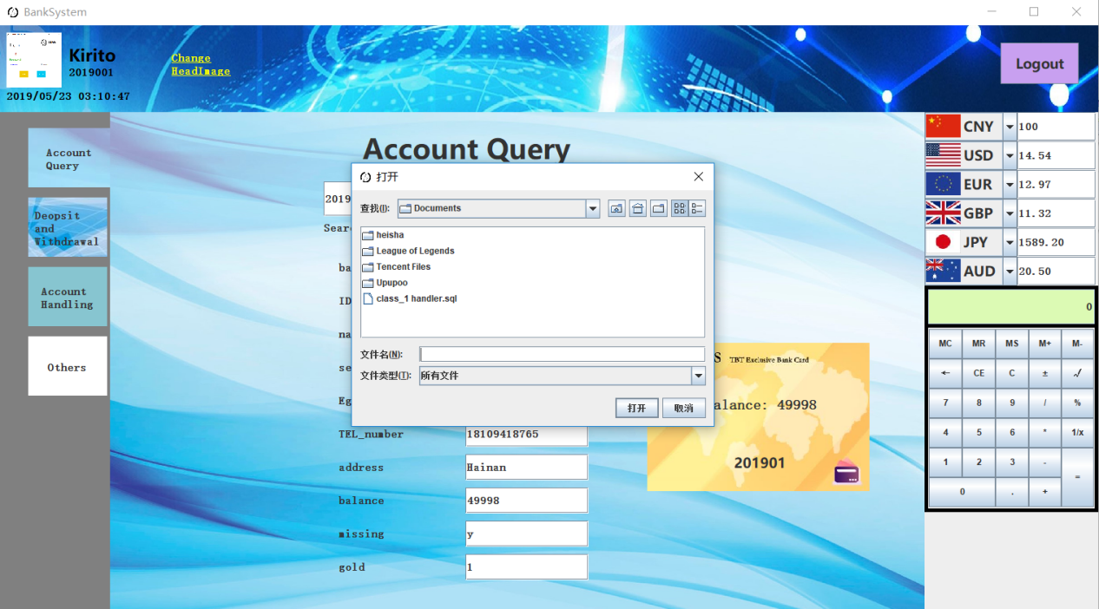

**//AccountHandlingPanel.java**

**package com.tbt.banksystem;**

**import java.awt.Color;**

**import java.awt.Font;**

**import java.awt.Graphics;**

**import java.awt.event.MouseAdapter;**

**import java.awt.event.MouseEvent;**

**import java.util.regex.Pattern;**

**import javax.swing.ButtonGroup;**

**import javax.swing.ImageIcon;**

**import javax.swing.JButton;**

**import javax.swing.JComboBox;**

**import javax.swing.JLabel;**

**import javax.swing.JPanel;**

**import javax.swing.JPasswordField;**

**import javax.swing.JRadioButton;**

**import javax.swing.JTextField;**

**import javax.swing.text.AttributeSet;**

**import javax.swing.text.BadLocationException;**

**import javax.swing.text.PlainDocument;**

**public class AccountHandlingPanel extends JPanel{**

**private JTextField fi1, fi2, fi3, fi4, fi5, fi6, fi7;**

**private JComboBox cb;**

**private int x1 = Start.width / 16,**

**x2 = (int)(Start.width / 4.5),**

**x3 = Start.width / 2,**

**y1 = (int)(Start.height / 7.2),**

**y2 = (int)(Start.height / 4.9),**

**y3 = (int)(Start.height / 3.7),**

**y4 = Start.height / 3,**

**y5 = (int)(Start.height / 2.5),**

**y6 = (int)(Start.height / 2.16),**

**y7 = (int)(Start.height / 1.9),**

**y8 = (int)(Start.height / 1.7),**

**y9 = (int)(Start.height / 1.5),**

**w15 = (int)(Start.width / 12.8),**

**w2 = (int)(Start.width / 9.6),**

**w22 = (int)(Start.width / 8.7),**

**w4 = (int)(Start.width / 4.8),**

**w5 = (int)(Start.width / 3.84),**

**h = Start.height / 20;**

**public AccountHandlingPanel() {**

**setLayout(null);**

**setOpaque(false);**

**JLabel L1 = new JLabel("User Registration Interface");**

**L1.setFont(new Font("微软雅黑",Font.BOLD,Start.width * 9 / 400));**

**L1.setBounds(Start.width / 5, Start.height / 50, (int)(Start.width / 2.4), Start.height / 10);**

**add(L1);**

**JLabel L3 = new JLabel("ID number:");**

**L3.setFont(Start.font30);**

**L3.setBounds(x1, y1, w2, h);**

**add(L3);**

**JLabel L3add = new JLabel("* Please enter 18 valid ID numbers");**

**L3add.setForeground(Color.RED);**

**L3add.setFont(Start.useFont);**

**L3add.setBounds(x3, y1, w4, h);**

**add(L3add);**

**fi2 = new JTextField();**

**fi2.setFont(Start.font25);**

**fi2.setBounds(x2, y1, w5,h);**

**fi2.setDocument(new PlainDocument() {**

**@Override**

**public void insertString(int offs, String str, AttributeSet a) throws BadLocationException {**

**if(str == null)**

**return;**

**if((getLength() + str.length()) <= 18)**

**super.insertString(offs, str, a);**

**}**

**});**

**add(fi2);**

**JLabel L9 = new JLabel("Password:");**

**L9.setFont(Start.font30);**

**L9.setBounds(x1, y2, w2, h);**

**add(L9);**

**fi6 = new JPasswordField();**

**fi6.setFont(Start.font25);**

**fi6.setBounds(x2, y2, w5,h);**

**add(fi6);**

**JLabel L10 = new JLabel("Confirm password:");**

**L10.setFont(Start.font30);**

**L10.setBounds(x1, y3, (int)(Start.width / 6.4), h);**

**add(L10);**

**fi7 = new JPasswordField();**

**fi7.setFont(Start.font25);**

**fi7.setBounds(x2, y3, w5,h);**

**add(fi7);**

**JLabel L4 = new JLabel("Full name:");**

**L4.setFont(Start.font30);**

**L4.setBounds(x1,y4,w2,h);**

**add(L4);**

**fi3 = new JTextField();**

**fi3.setFont(Start.font25);**

**fi3.setBounds(x2, y4, w22,h);**

**add(fi3);**

**final JRadioButton jr1 = new JRadioButton("male");**

**final JRadioButton jr2 = new JRadioButton("female");**

**ButtonGroup group1 = new ButtonGroup();**

**jr1.setBackground(Color.white);**

**jr2.setBackground(Color.white);**

**jr1.setFont(Start.font25);**

**jr2.setFont(Start.font25);**

**jr1.setBounds((int)(Start.width/2.8), y4, Start.width/16, h);**

**jr2.setBounds((int)(Start.width/2.4), y4, Start.width/15, h);**

**group1.add(jr1);**

**group1.add(jr2);**

**add(jr1);**

**add(jr2);**

**JLabel L2 = new JLabel("Phone number:");**

**L2.setFont(Start.font30);**

**L2.setBounds(x1, y5, (int)(Start.width / 7.68), h);**

**add(L2);**

**JLabel L2add = new JLabel("* Please enter 11 valid Phone numbers");**

**L2add.setForeground(Color.RED);**

**L2add.setFont(Start.useFont);**

**L2add.setBounds(x3, y5, w4, h);**

**add(L2add);**

**fi1 = new JTextField();**

**fi1.setFont(Start.font25);**

**fi1.setBounds(x2, y5, w5,50);**

**fi1.setDocument(new PlainDocument() {**

**@Override**

**public void insertString(int offs, String str, AttributeSet a) throws BadLocationException {**

**if(str == null)**

**return;**

**if((getLength() + str.length()) <= 11)**

**super.insertString(offs, str, a);**

**}**

**});**

**add(fi1);**

**JLabel L5 = new JLabel("Nation:");**

**L5.setFont(Start.font30);**

**L5.setBounds(x1,y6,w2,h);**

**add(L5);**

**fi4 = new JTextField();**

**fi4.setFont(Start.font25);**

**fi4.setBounds(x2, y6, w22,h);**

**add(fi4);**

**JLabel L8 = new JLabel("address:");**

**L8.setFont(Start.font30);**

**L8.setBounds(x1,y7,w5,h);**

**add(L8);**

**final String [] a = {"Hainan","Guangdong","Henan","Hubei","Hunan","Jiangsu","Zhejiang","Anhui","Fujian","Jiangxi","Shandong",**

**"Taiwan","Shanxi","Hebei","Jilin","Liaoning","Sichuan","Guizhou","Yunnan","Shaanxi","Gansu","Qinghai",**

**"Heilongjiang","Beijing","Tianjin","Shanghai","Chongqing","Tibet","Inner Mongolia","Guangxi",**

**"Ningxia","Xinjiang","Hong Kong","Macao"};**

**cb=new JComboBox(a);**

**cb.setBounds(x2, y7, w22, h);**

**cb.setFont(Start.font25);**

**add(cb);**

**JLabel L7 = new JLabel("mailbox:");**

**L7.setFont(Start.font30);**

**L7.setBounds(x1,y8,w2,h);**

**add(L7);**

**fi5 = new JTextField();**

**fi5.setFont(Start.font25);**

**fi5.setBounds(x2, y8, w5,h);**

**add(fi5);**

**JButton B1 = new JButton("register");**

**B1.setFont(Start.font30);**

**B1.setBounds((int)(Start.width/7.4),y9,w2,h);**

**B1.addMouseListener(new MouseAdapter() {**

**@Override**

**public void mouseClicked(MouseEvent e) {**

**if(!fi2.getText().equals("")&&!fi3.getText().equals("")&&!fi4.getText().equals("")&&!fi5.getText().equals("")**

**&&!fi1.getText().equals("")&&!fi4.getText().equals("")&&!fi6.getText().equals("")&&!fi7.getText().equals("")) {**

**if(Pattern.compile("\\d{18}").matcher(fi2.getText()).matches()) {**

**if(Pattern.compile("\\d{11}").matcher(fi1.getText()).matches()) {**

**String c = "";**

**if(jr1.isSelected()||jr2.isSelected()) {**

**if(jr1.isSelected())**

**c = "m";**

**if(jr2.isSelected())**

**c = "f";**

**String password = fi6.getText();**

**if(password.equals(fi7.getText())) {**

**String bankCard = Start.getCard();**

**if(Start.signUp(bankCard, fi2.getText(), fi3.getText(), c, fi4.getText(), fi1.getText(), a[cb.getSelectedIndex()], password)) {**

**Start.deleteCard(bankCard);**

**Start.bankerrmsg("<html>Success!<br>your bankcard is<br>" + bankCard + "</html>");**

**}**

**else {**

**Start.bankerrmsg("Registration failed!");**

**}**

**}**

**else {**

**Start.bankerrmsg("Password should be same!");**

**}**

**}**

**else {**

**Start.bankerrmsg("Please choose sex");**

**}**

**}**

**else {**

**Start.bankerrmsg("Check your phone number");**

**}**

**}**

**else {**

**Start.bankerrmsg("Check your ID card");**

**}**

**}**

**else {**

**Start.bankerrmsg("Please fill in your information");**

**}**

**}**

**});**

**add(B1);**

**JButton B2 = new JButton("Reset");**

**B2.setFont(Start.font30);**

**B2.setBounds(x3,y9,w15,h);**

**add(B2);**

**B2.addMouseListener(new MouseAdapter() {**

**@Override**

**public void mouseClicked(MouseEvent e) {**

**refresh();**

**}**

**});**

**}**

**public void refresh() {**

**fi1.setText("");**

**fi2.setText("");**

**fi3.setText("");**

**fi4.setText("");**

**fi5.setText("");**

**fi6.setText("");**

**fi7.setText("");**

**cb.setSelectedIndex(0);**

**repaint();**

**}**

**@Override**

**protected void paintComponent(Graphics g) {**

**super.paintComponent(g);**

**ImageIcon bg = new ImageIcon(getClass().getResource("/com/tbt/banksystem/image/accounthandling_bg.jpg"));**

**g.drawImage(bg.getImage(), 0, 0, getWidth(), getHeight(), bg.getImageObserver());**

**}**

**}**

**//ZxgsbbPanel.java**

**package com.tbt.banksystem;**

**import java.awt.Color;**

**import java.awt.Font;**

**import java.awt.Graphics;**

**import java.awt.Insets;**

**import java.awt.event.KeyAdapter;**

**import java.awt.event.KeyEvent;**

**import java.awt.event.MouseAdapter;**

**import java.awt.event.MouseEvent;**

**import javax.swing.ImageIcon;**

**import javax.swing.JButton;**

**import javax.swing.JLabel;**

**import javax.swing.JPanel;**

**import javax.swing.JTextField;**

**public class ZxgsbbPanel extends JPanel {**

**private JPanel contentPane;**

**public newPanel panel[];**

**private int pw = (int)(Start.width / 1.3),**

**ph = (int)(Start.height / 1.2);**

**public int inPanel = 0;**

**public ZxgsbbPanel()**

**{**

**int x1,x2,y1,y2,w,h;**

**x1 = (int)(Start.width / 4.2);**

**x2 = (int)(Start.width / 2.6);**

**y1 = (int)(Start.height / 4.9);**

**y2 = (int)(Start.height / 2.16);**

**w = Start.width / 10;**

**h = Start.height / 12;**

**setLayout(null);**

**contentPane= new JPanel();**

**contentPane.setLayout(null);**

**contentPane.setOpaque(false);**

**contentPane.setBounds(0, 0, pw, ph);**

**panel = new newPanel[4];**

**String headLabelStr[] = {"log off", "report loss", "cancel loss", "reapply"};**

**String inputLabelStr[] = {"ID Card", "Bank Card", "Bank Card", "ID Card"};**

**for(int i = 0; i < panel.length; i++)**

**panel[i] = new newPanel(i, headLabelStr[i], inputLabelStr[i]);**

**JButton b1= new JButton("log off");**

**b1.setFont(Start.font30);**

**b1.setBounds(x1, y1, w, h);**

**b1.addMouseListener(new MouseAdapter(){**

**@Override**

**public void mouseClicked(MouseEvent e) {**

**remove(contentPane);**

**add(panel[0]);**

**inPanel = 0;**

**repaint();**

**validate();**

**}**

**});**

**JButton b2= new JButton("report loss");**

**b2.setFont(Start.font30);**

**b2.setBounds(x2, y1, w, h);**

**b2.setMargin(new Insets(0, 0, 0, 0));**

**b2.addMouseListener(new MouseAdapter(){**

**@Override**

**public void mouseClicked(MouseEvent e) {**

**remove(contentPane);**

**add(panel[1]);**

**inPanel = 1;**

**repaint();**

**validate();**

**}**

**});**

**JButton b3= new JButton("cancel loss");**

**b3.setFont(Start.font30);**

**b3.setBounds(x1, y2, w, h);**

**b3.setMargin(new Insets(0, 0, 0, 0));**

**b3.addMouseListener(new MouseAdapter(){**

**@Override**

**public void mouseClicked(MouseEvent e) {**

**remove(contentPane);**

**add(panel[2]);**

**inPanel = 2;**

**repaint();**

**validate();**

**}**

**});**

**JButton b4 = new JButton("reapply");**

**b4.setBounds(x2, y2, w, h);**

**b4.setFont(Start.font30);**

**b4.addMouseListener(new MouseAdapter() {**

**@Override**

**public void mouseClicked(MouseEvent e) {**

**remove(contentPane);**

**add(panel[3]);**

**inPanel = 3;**

**repaint();**

**validate();**

**}**

**});**

**contentPane.add(b1);**

**contentPane.add(b2);**

**contentPane.add(b3);**

**contentPane.add(b4);**

**add(contentPane);**

**}**

**public void back(int i) {**

**remove(panel[i]);**

**panel[i].refresh();**

**add(contentPane);**

**repaint();**

**}**

**public void Next(int i) {**

**String card = panel[i].inputField.getText();**

**boolean b = false;**

**switch (i) {**

**case 0:**

**if(Start.getUserres(2, card) != null) {**

**Start.logOff(card);**

**panel[i].messageLabel.setText("<html>You cannot use this card.</html>");**

**b = true;**

**}**

**break;**

**case 1:**

**if(Start.getUserres(1, card) != null) {**

**Start.lost(true, card);**

**panel[i].messageLabel.setText("<html>This card will Decline Transaction</html>");**

**b = true;**

**}**

**break;**

**case 2:**

**if(Start.getUserres(1, card) != null) {**

**Start.lost(false, card);**

**panel[i].messageLabel.setText("<html>Turn transaction back ON</html>");**

**b = true;**

**}**

**break;**

**case 3:**

**if(Start.getUserres(2, card) != null) {**

**String newcard = Start.getCard();**

**Start.reapply(newcard, card);**

**panel[i].messageLabel.setText("<html>Your new bankcard number is " + newcard + "</html>");**

**b = true;**

**}**

**break;**

**}**

**panel[i].clicked(b);**

**}**

**@Override**

**protected void paintComponent(Graphics g) {**

**super.paintComponent(g);**

**ImageIcon bg = new ImageIcon(getClass().getResource("/com/tbt/banksystem/image/zxgsbb_bg.jpg"));**

**g.drawImage(bg.getImage(), 0, 0, getWidth(), getHeight(), bg.getImageObserver());**

**}**

**class newPanel extends JPanel{**

**private int panelnum;**

**public JTextField inputField;**

**private JLabel successLabel;**

**public JLabel messageLabel;**

**public JButton backButton, nextButton, finishButton;**

**public newPanel(int i, String headString, String inputString) {**

**panelnum = i;**

**setLayout(null);**

**setOpaque(false);**

**setBounds(0, 0, pw, ph);**

**JLabel headLabel = new JLabel(headString);**

**headLabel.setFont(new Font("微软雅黑",Font.BOLD,Start.width * 9 / 400));**

**headLabel.setBounds((int)(Start.width / 6.4), Start.height / 54, (int)(Start.width / 2.4), (int)(Start.height / 10.8));**

**headLabel.setHorizontalAlignment(JLabel.CENTER);**

**add(headLabel);**

**JLabel inputLabel= new JLabel(inputString);**

**inputLabel.setFont(Start.font30);**

**inputLabel.setBounds((int)(Start.width / 6.4), (int)(Start.height / 5.4), (int)(Start.width / 9.6), (int)(Start.height / 21.6));**

**add(inputLabel);**

**inputField = new JTextField();**

**inputField.setFont(Start.font25);**

**inputField.setBounds((int)(Start.width / 3.2), (int)(Start.height / 5.4), (int)(Start.width / 3.84),(int)(Start.height / 21.6));**

**inputField.addKeyListener(new KeyAdapter() {**

**@Override**

**public void keyPressed(KeyEvent e) {**

**if(e.getKeyCode() == KeyEvent.VK_ENTER)**

**Next(panelnum);**

**}**

**});**

**add(inputField);**

**backButton = new JButton("Back");**

**backButton.setFont(Start.font30);**

**backButton.setBounds((int)(Start.width / 4.3), (int)(Start.height / 2.7), (int)(Start.width / 9.6), (int)(Start.height / 21.6));**

**backButton.addMouseListener(new MouseAdapter() {**

**@Override**

**public void mouseClicked(MouseEvent e) {**

**back(panelnum);**

**}**

**});**

**add(backButton);**

**nextButton = new JButton("Next");**

**nextButton.setFont(Start.font25);**

**nextButton.setBounds((int)(Start.width / 2.56), (int)(Start.height / 2.7), (int)(Start.width / 9.6),(int)(Start.height / 21.6));**

**nextButton.addMouseListener(new MouseAdapter() {**

**@Override**

**public void mouseClicked(MouseEvent e) {**

**Next(panelnum);**

**}**

**});**

**add(nextButton);**

**successLabel = new JLabel("Success");**

**successLabel.setFont(Start.font40);**

**successLabel.setBounds((int)(Start.width / 3.2),(int)(Start.height / 2.16),(int)(Start.width / 9.6),(int)(Start.height / 10.8));**

**successLabel.setForeground(Color.GREEN);**

**messageLabel = new JLabel();**

**messageLabel.setFont(Start.font30);**

**messageLabel.setBounds((int)(Start.width / 4.3), (int)(Start.height / 1.8), (int)(Start.width / 3.2), (int)(Start.height / 10.8));**

**finishButton = new JButton("Done");**

**finishButton.setFont(Start.font30);**

**finishButton.setBounds((int)(Start.width / 3.2),(int)(Start.height / 1.44),(int)(Start.width / 9.6),(int)(Start.height / 21.6));**

**finishButton.addMouseListener(new MouseAdapter() {**

**@Override**

**public void mouseClicked(MouseEvent e) {**

**back(panelnum);**

**}**

**});**

**}**

**public void clicked(boolean b) {**

**if(b) {**

**add(successLabel);**

**add(messageLabel);**

**add(finishButton);**

**}**

**else {**

**nextButton.setVisible(false);**

**Start.bankerrmsg("Please check your card");**

**}**

**repaint();**

**}**

**public void refresh() {**

**inputField.setText(null);**

**remove(successLabel);**

**remove(messageLabel);**

**remove(finishButton);**

**}**

**}**

**}**

**//Calculator.java**

**package com.tbt.banksystem;**

**import java.awt.BorderLayout;**

**import java.awt.Color;**

**import java.awt.Dimension;**

**import java.awt.GridBagConstraints;**

**import java.awt.GridBagLayout;**

**import java.awt.Insets;**

**import java.awt.event.MouseAdapter;**

**import java.awt.event.MouseEvent;**

**import javax.swing.JButton;**

**import javax.swing.JPanel;**

**import javax.swing.JTextField;**

**import javax.swing.border.EmptyBorder;**

**public class Calculator extends JPanel{**

**private static JTextField text;**

**private JPanel btnpanel;**

**private Calcbtn Cbtn[][] = new Calcbtn[6][5];**

**private static String suanshi = "", ans = "", js = "";**

**public static boolean haveans = false, havejs = false;**

**public Calculator() {**

**String str[][] = new String[][] {**

**{"MC", "MR", "MS", "M+", "M-" ,},**

**{"←" , "CE", "C" , "±" , "√" ,},**

**{"7" , "8" , "9" , "/" , "%" ,},**

**{"4" , "5" , "6" , "*" , "1/x",},**

**{"1" , "2" , "3" , "-" , "=" ,},**

**{"0" , "0" , "." , "+" , "=" ,}**

**};**

**char c[][] = new char[][] {**

**{'a', 'b', 'c', 'd', 'e',},**

**{'f', 'g', 'h', 'i', '√',},**

**{'7', '8', '9', '/', '%',},**

**{'4', '5', '6', '*', 'j',},**

**{'1', '2', '3', '-', 'k',},**

**{'0', '0', '.', '+', 'k',}**

**};**

**setBorder(new EmptyBorder(5, 5, 5, 5));**

**setLayout(new BorderLayout(5, 5));**

**text = new JTextField();**

**text.setPreferredSize(new Dimension(0, Start.height / 18));**

**text.setHorizontalAlignment(JTextField.RIGHT);**

**text.setFont(Start.useFont);**

**text.setText("0");**

**text.setBackground(new Color(220, 250, 180));**

**text.setEditable(false);**

**add(text, BorderLayout.NORTH);**

**btnpanel = new JPanel();**

**GridBagLayout gbl = new GridBagLayout();**

**btnpanel.setLayout(gbl);**

**add(btnpanel, BorderLayout.CENTER);**

**GridBagConstraints gbc = new GridBagConstraints();**

**for(int i = 0; i < 6; i++)**

**for(int j = 0; j < 5; j++) {**

**if(i == 5 && (j == 1 || j == 4))**

**continue;**

**gbc.gridx = j;**

**gbc.gridy = i;**

**gbc.weightx = Start.width / 22;**

**gbc.weighty = Start.height / 33;**

**gbc.gridwidth = 1;**

**gbc.gridheight = 1;**

**gbc.fill = GridBagConstraints.BOTH;**

**if(i == 4 && j == 4)**

**gbc.gridheight = 2;**

**else if(i == 5 && j == 0)**

**gbc.gridwidth = 2;**

**Cbtn[i][j] = new Calcbtn(str[i][j], c[i][j]);**

**if(i > 1 && j < 4 || (i == 1 || i == 2) && j == 4)**

**Cbtn[i][j].canadc = true;**

**Cbtn[i][j].calcbtn.setMargin(new Insets(0, 0, 0, 0));**

**gbl.setConstraints(Cbtn[i][j].calcbtn, gbc);**

**btnpanel.add(Cbtn[i][j].calcbtn);**

**}**

**}**

**public static JTextField getTf() {**

**return text;**

**}**

**public static String getSuanshi() {**

**return suanshi;**

**}**

**public static void setSuanshi(String str) {**

**suanshi = str;**

**}**

**public static String getAns() {**

**return ans;**

**}**

**public static void setAns(String str) {**

**ans = str;**

**}**

**public static String getJs() {**

**return js;**

**}**

**public static void setJs(String js) {**

**Calculator.js = js;**

**}**

**class Calcbtn {**

**public JButton calcbtn;**

**public char btnchar;**

**public boolean canadc = false;**

**public Calcbtn(String str, char c) {**

**calcbtn = new JButton(str);**

**btnchar = c;**

**calcbtn.addMouseListener(new MouseAdapter() {**

**@Override**

**public void mouseClicked(MouseEvent e) {**

**if(Calculator.haveans && btnchar == 'k') {**

**Calculator.setSuanshi(Calculator.getAns() + Calculator.getJs());**

**}**

**if(Calculator.haveans) {**

**if(Character.isDigit(btnchar)) {**

**Calculator.setSuanshi("");**

**Calculator.setAns("");**

**Calculator.haveans = false;**

**Calculator.getTf().setText("0");**

**}**

**else if(!Character.isLetterOrDigit(btnchar)) {**

**Calculator.setSuanshi(Calculator.getAns());**

**Calculator.setAns("");**

**Calculator.haveans = false;**

**Calculator.getTf().setText(Calculator.getAns());**

**if(btnchar !='√') {**

**Calculator.setJs("");**

**Calculator.havejs = false;**

**}**

**}**

**}**

**String xs = Calculator.getSuanshi();**

**if(canadc) {**

**Calculator.setSuanshi(xs + btnchar);**

**Calculator.getTf().setText(Calculator.getSuanshi());**

**}**

**else if(btnchar == 'f') {**

**if(xs.length() > 0) {**

**Calculator.setSuanshi(xs.substring(0, xs.length() - 1));**

**xs = Calculator.getSuanshi();**

**if(xs.length() > 0)**

**Calculator.getTf().setText(Calculator.getSuanshi());**

**else**

**Calculator.getTf().setText("0");**

**Calculator.setAns("");**

**Calculator.haveans = false;**

**Calculator.setJs("");**

**Calculator.havejs = false;**

**}**

**}**

**else if(btnchar == 'g' || btnchar == 'h') {**

**Calculator.setSuanshi("");**

**Calculator.getTf().setText("0");**

**Calculator.setAns("");**

**Calculator.haveans = false;**

**Calculator.setJs("");**

**Calculator.havejs = false;**

**}**

**else if(btnchar == 'k') {**

**int i = 0, a = 0, b = 0;**

**char ch, sf = 'n';**

**boolean turna = true, agen = false, bgen = false, afu = false, bfu = false, error = false;**

**for(; i < xs.length(); i++) {**

**ch = xs.charAt(i);**

**if(Character.isDigit(ch)) {**

**if(turna)**

**a = a * 10 + ch - 48;**

**else**

**b = b * 10 + ch - 48;**

**}**

**else if(!Character.isLetterOrDigit(ch)) {**

**if(ch == '√') {**

**if(turna)**

**agen = true;**

**else**

**bgen = true;**

**}**

**else if(turna && a == 0 && ch == '-')**

**afu = true;**

**else if(!turna && b == 0 && ch == '-')**

**bfu = true;**

**else {**

**sf = ch;**

**if(turna)**

**turna = false;**

**else**

**error = true;**

**}**

**}**

**}**

**i = 1;**

**if(!Calculator.havejs && xs.length() > 1) {**

**for(;i < xs.length(); i++)**

**if(!Character.isDigit(xs.charAt(i)))**

**break;**

**Calculator.setJs(xs.substring(i, xs.length()));**

**Calculator.havejs = true;**

**}**

**if(error)**

**Calculator.getTf().setText("ERROR:目前只支持计算两个数");**

**else if(sf != 'n') {**

**if(agen)**

**;**

**if(bgen)**

**;**

**if(afu)**

**a = -a;**

**if(bfu)**

**b = -b;**

**switch(sf) {**

**case '+':**

**a += b;**

**break;**

**case '-':**

**a -= b;**

**break;**

**case '*':**

**a *= b;**

**break;**

**case '/':**

**a /= b;**

**break;**

**case '%':**

**a %= b;**

**break;**

**}**

**Calculator.setAns("" + a);**

**Calculator.haveans = true;**

**Calculator.getTf().setText("" + a);**

**}**

**}**

**}**

**});**

**}**

**}**

**}**

**PART OF MYSQL**

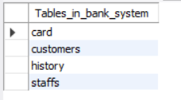

**create database BANK_SYSTEM;**

**use BANK_SYSTEM;**

**create table card(**

**card_number int(6) primary key auto_increment**

**);**

**insert into card**

**values('201903');**

**insert into card value();**

**insert into card value();**

**insert into card value();**

**insert into card value();**

**insert into card value();**

**insert into card value();**

**insert into card value();**

**create table staffs(**

**job_number int(7) primary key,**

**name varchar(20),**

**sex char(1),**

**age int(2),**

**ID_card bigint(18),**

**password int(7),**

**photo blob**

**);**

**insert into staffs**

**values('2019001','Kirito','m','19','623001199912081516','9911001',null);**

**insert into staffs**

**values('2019002','Jerry','m','19','460007200011280017','9911002',null);**

**insert into staffs**

**values('2019003','gunly','m','19','500243200010083512','9911003',null);**

**insert into staffs**

**values('2019004','Paul','m','19','650102200006060810','9911004',null);**

**create table customers(**

**bank_card int(6) primary key,**

**ID_card bigint(18) unique,**

**name varchar(20),**

**sex char(1),**

**Eg varchar(5),**

**TEL_number bigint(11),**

**address varchar(20),**

**balance int(12),**

**missing char,**

**gold int(12),**

**password int(6)**

**);**

**insert into customers values('201901','623001199912081516','Kirito','m','藏','18109418765','Hainan', 50000, 'n', 0, 123456);**

**insert into customers values('201902','500243200010083512','Gunly','m','汉','15523837164','Hainan', 20000, 'n', 0, 123456);**

**create table history(**

**bank_card int(6),**

**deal_time varchar(30),**

**deal_style varchar(10),**

**deal_money int**

**);**

**！ You need reset your MYSQL password&user-name in JDBC code(Start.java).**

**This can help you to connect your database successfully.**